**Creating Laravel CRUD operations for a "products"**

**Step 1: Set up Laravel**

* Install Laravel on your system by following the official documentation: <https://laravel.com/docs/installation>

**Step 2: Set up the Database**

* Create a new database for your project.

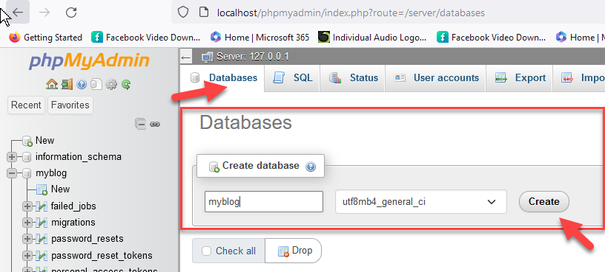

* Configure your database credentials in the .env file located in the root directory of your Laravel project.

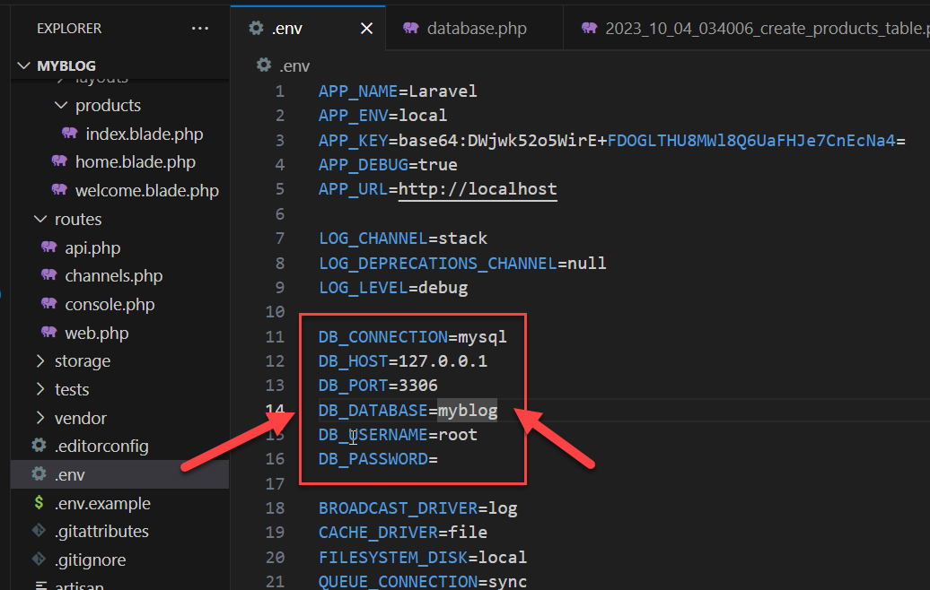

**Step 3: Generate the Product Model and Migration**

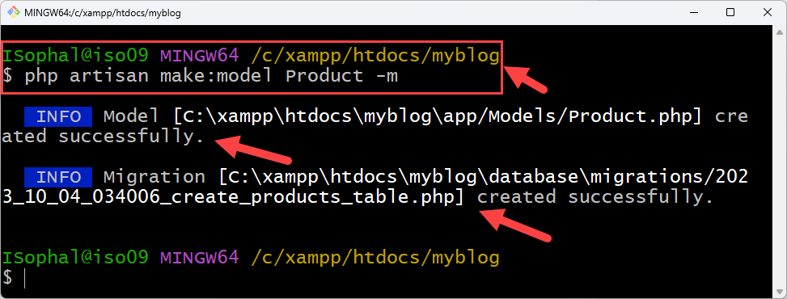

**php artisan make:model Product -m**

**Step 4: Define the Product Migration**

Open the migration file (e.g., database/migrations/timestamp_create_products_table.php)

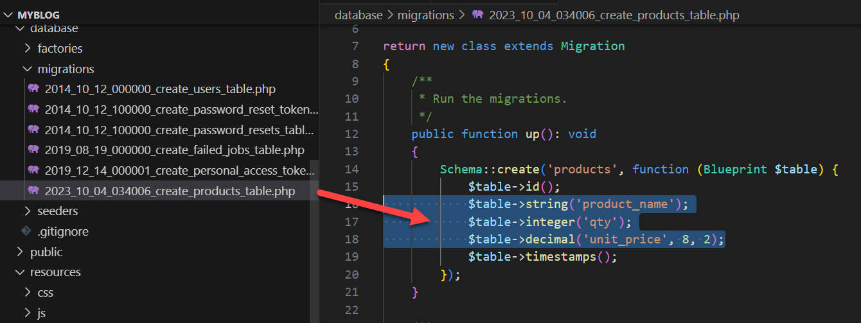

Schema::create('products', function (Blueprint $table) {

$table->id();

$table->string('product_name');

$table->integer('qty');

$table->decimal('unit_price', 8, 2);

$table->timestamps();

});

Step 5: Run the Migration

php artisan migrate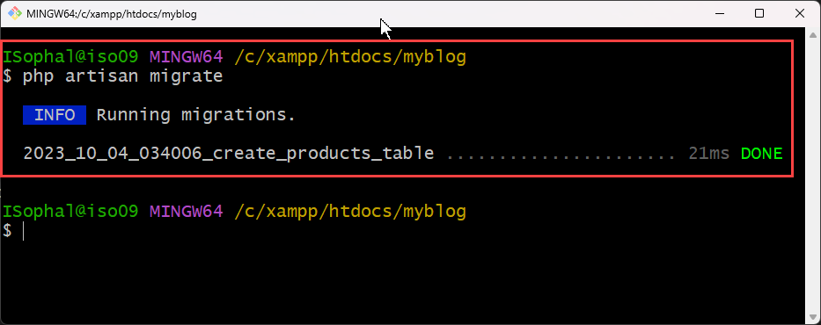

if error migrate

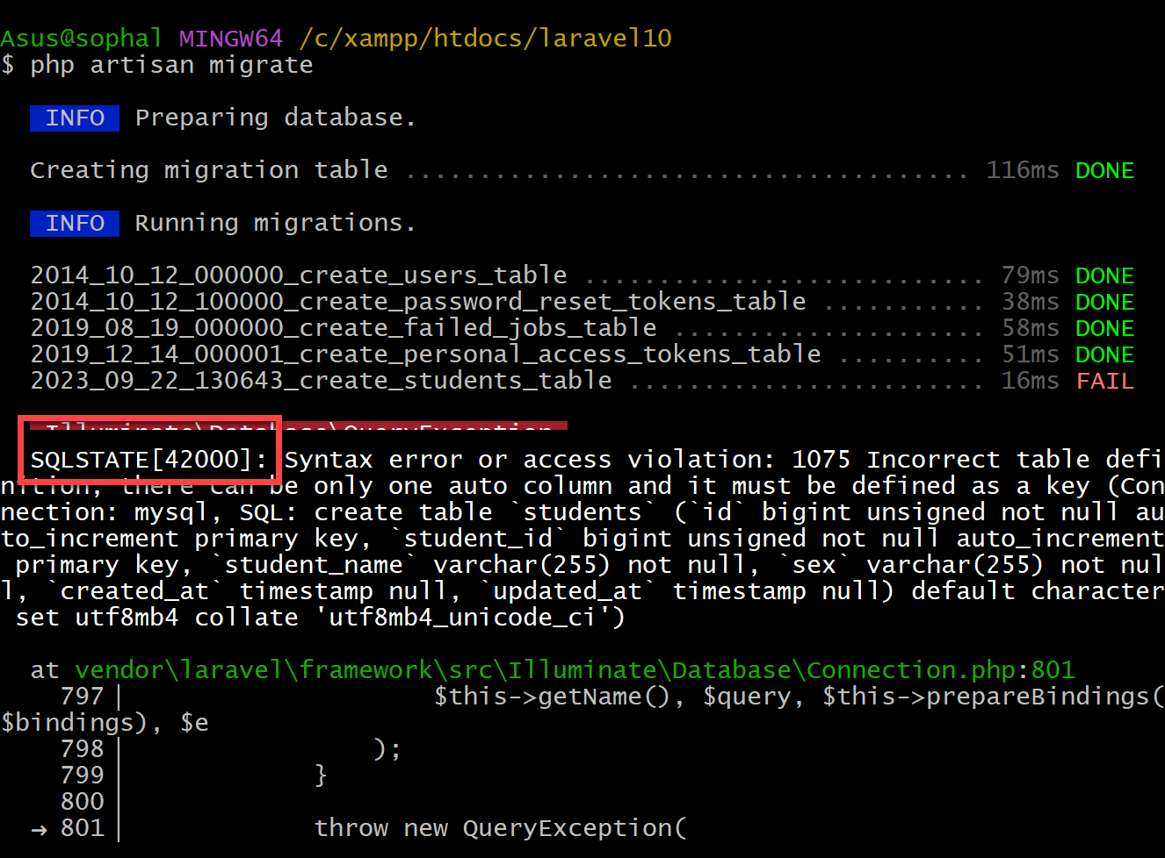

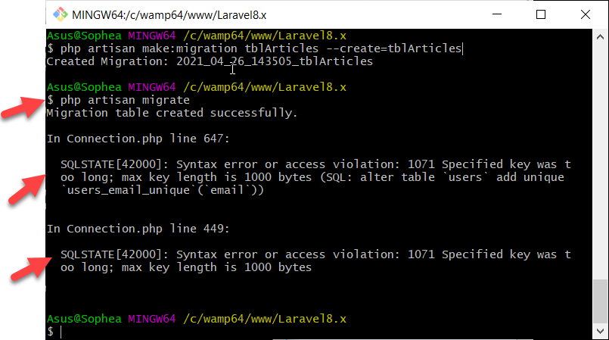

SQLSTATE[42000]: Syntax error or access violation: 1071 Specified key was too long; max key length is 767 bytes

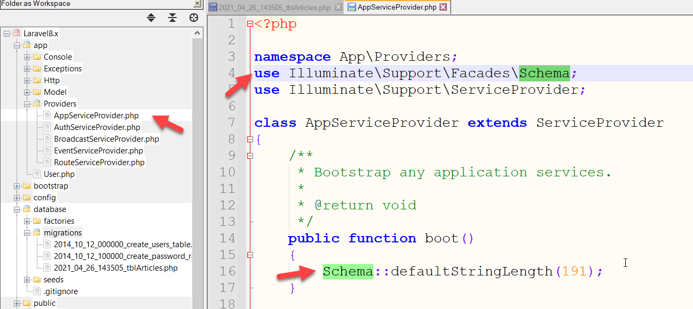

ដូច្នេះយើងត្រូវចូលទៅកាន់ Database ដើម្បីលុប Table Default នោះជាមុនសិន

ចូលទៅកាន់ phpMyAdmin

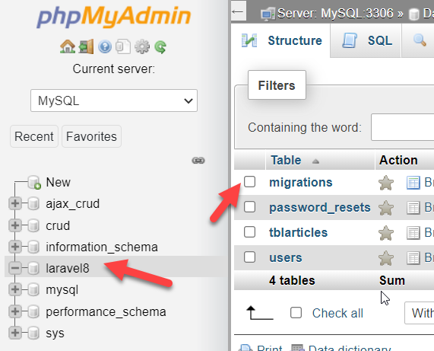

Solution:

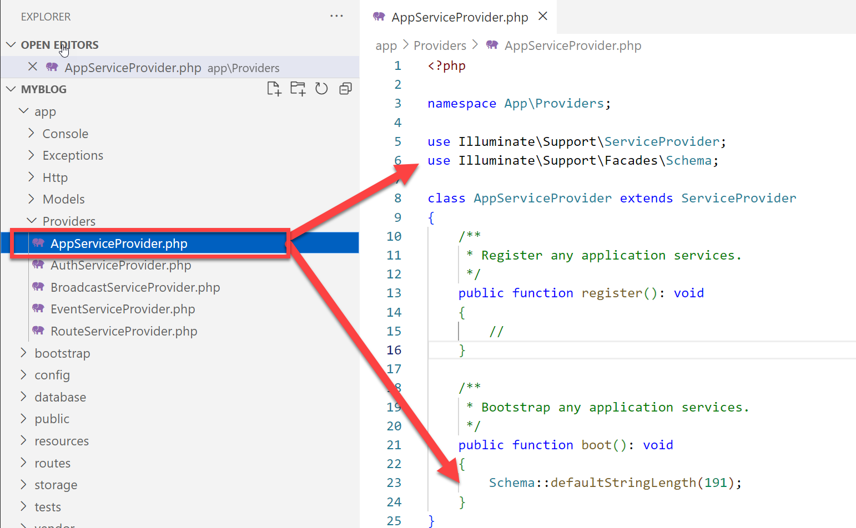

Copy code

use Illuminate\Support\Facades\Schema;

Schema::defaultStringLength(191);

Config Database in MySQL Server

នៅក្នុង Folder Project -> config-> database.php អ្នកនឹងឃើញចំនុចដូចរូបខាងក្រោមនេះ ៖

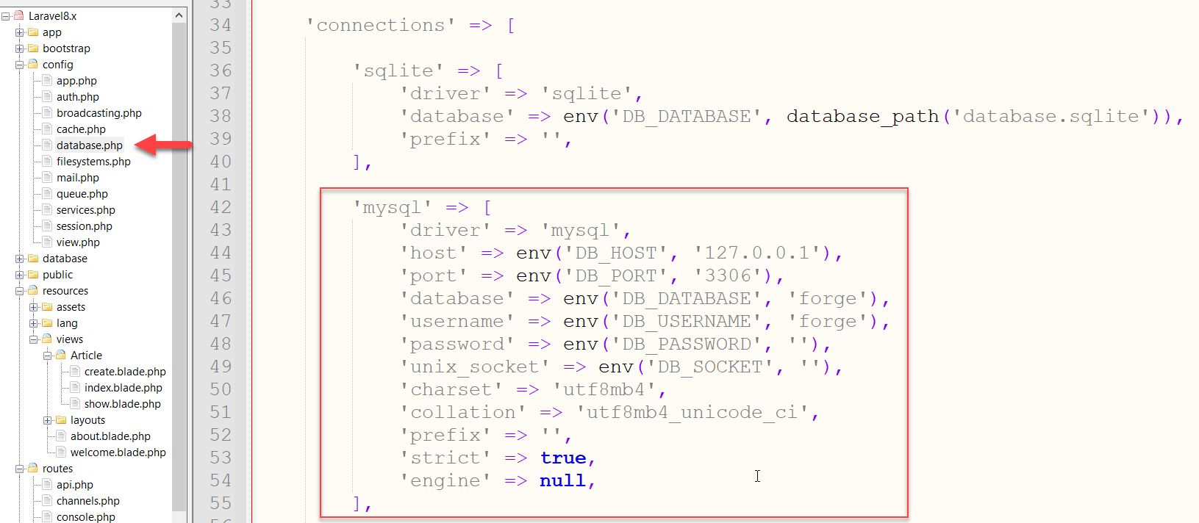

DB_DATABASE:  
**DB-Name**

DB_USERNAME

**root**

អ្នកអាចមើលឃើញនៅរូបខាងលើនោះគឺជាការកំណត់រចនាសម្ព័ន្ធការតភ្ជាប់ laravel ជាមួយនឹង មូលដ្ឋានទិន្នន័យ MySQL ប៉ុន្តែវាមិនមែនការធ្វើបែបនេះទេ។ អ្នកអាចធ្វើការកំណត់រចនាសម្ព័ន្ធមូលដ្ឋានទិន្នន័យ (database) របស់អ្នកនៅ .evn  ដូចរូបខាងក្រោម៖

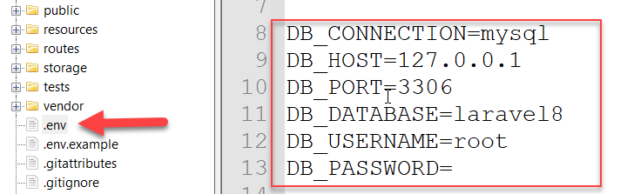

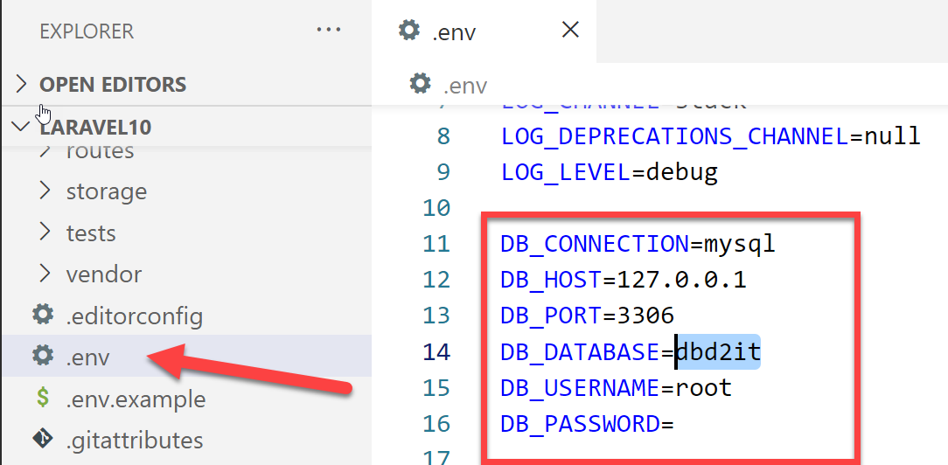

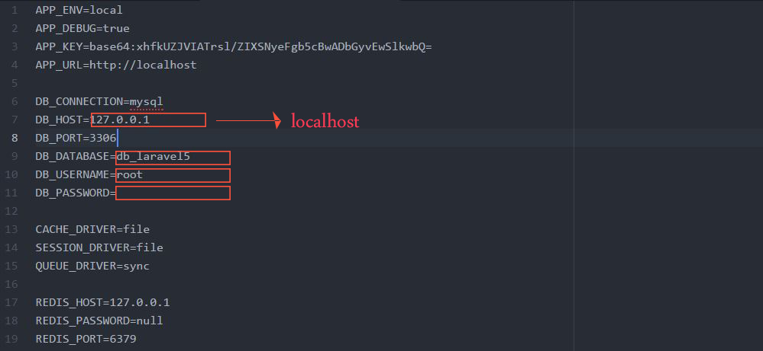

ចំណាំ៖  
អ្នកអាចកំណត់រចនាសម័្ពន្ធមូលដ្ឋានទិន្នន័យ (database) របស់អ្នកក្នុងឯកសារ .env  ដូច្នេះមិនផ្លាស់ប្តូរអ្វីនោះទេនៅ app\config\database.php ៕

Copy code

php artisan migrate:reset

php artisan migrate

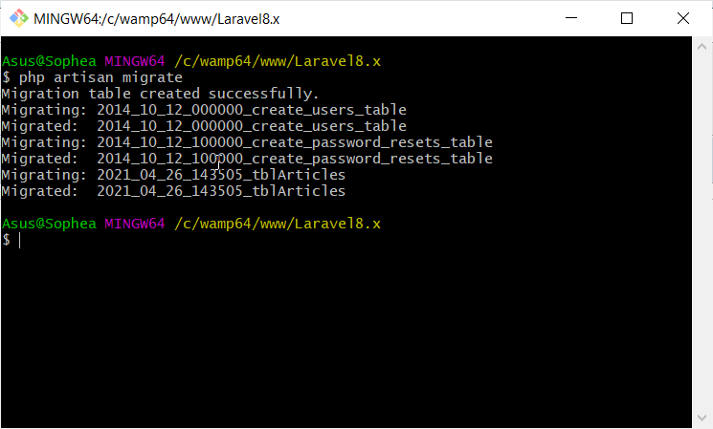

**Step 6: Create Routes**

Open the routes/web.php file

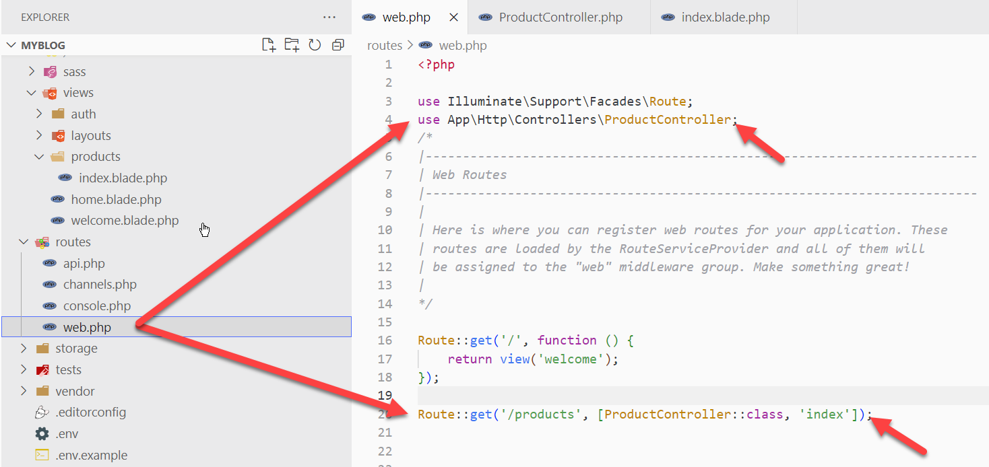

use App\Http\Controllers\ProductController;

Route::get('/products', [ProductController::class, 'index']);

**Step 7: Create the Product Controller**

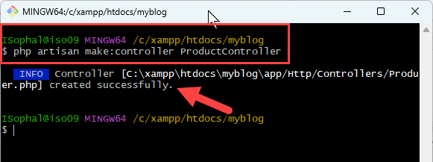

**php artisan make:controller ProductController**

Open the app/Http/Controllers/ProductController.php

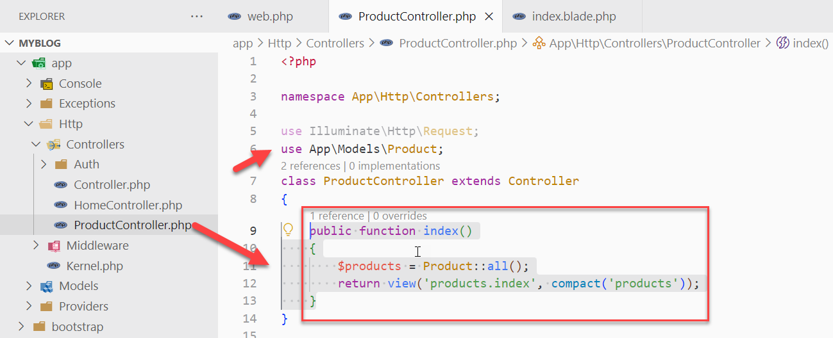

**Step8: Create Views**

Create the following view files in the resources/views/**products** directory:

* **index.blade.php (for displaying the list of products)**

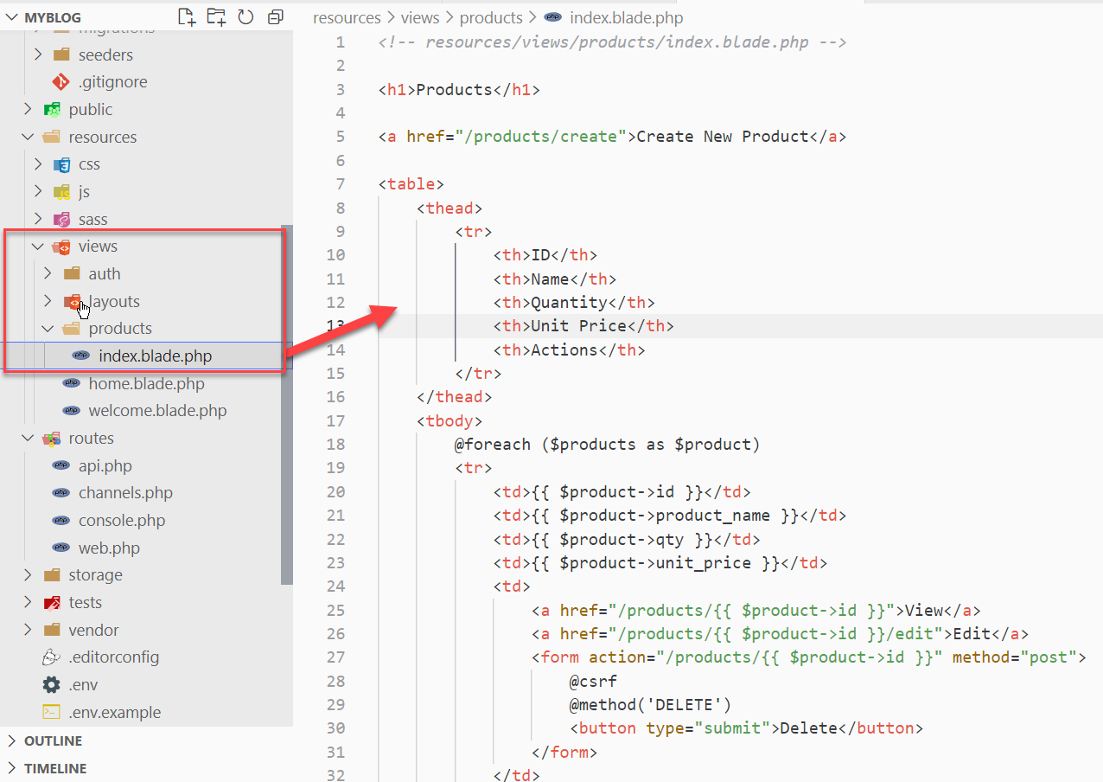

Here's an example of the index.blade.php file:

*<!-- resources/views/products/index.blade.php -->*

<h1>Products</h1>

<a href="/products/create">Create New Product</a>

<table>

    <thead>

        <tr>

            <th>ID</th>

            <th>Name</th>

            <th>Quantity</th>

            <th>Unit Price</th>

            <th>Actions</th>

        </tr>

    </thead>

    <tbody>

        @foreach ($products as $product)

        <tr>

            <td>{{ $product->id }}</td>

            <td>{{ $product->product_name }}</td>

            <td>{{ $product->qty }}</td>

            <td>{{ $product->unit_price }}</td>

            <td>

                <a href="/products/{{ $product->id }}">View</a>

                <a href="/products/{{ $product->id }}/edit">Edit</a>

                <form action="/products/{{ $product->id }}" method="post">

                    @csrf

                    @method('DELETE')

                    <button type="submit">Delete</button>

                </form>

            </td>

        </tr>

        @endforeach

    </tbody>

</table>

**Insert Data into Table products**

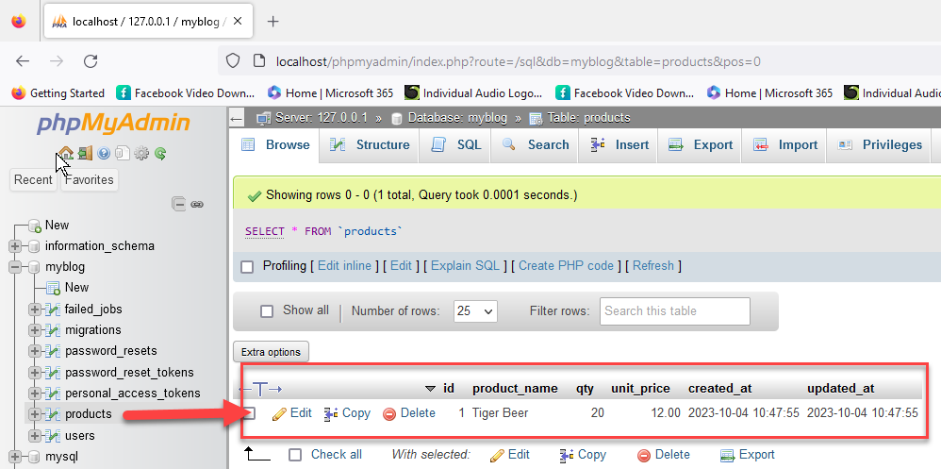

**Step 9: Test the Application**

* Open your web browser and visit http://localhost:8000/products to see the list of products.

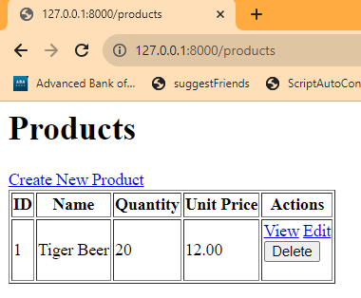

**To be continue …**

**To integrate AdminLTE into CRUD operations for a "products" module**

Step 1: Install AdminLTE

Step 2: Set up the Layout

Step 3: Create the "Products" Views

Step 4: Set up the Routes

Step 5: Create the Controller

Step 6: Customize the Views

Step 7: Test the CRUD Operations

=======================================

**Step 1: Install AdminLTE**

 Using Composer (for Laravel projects)

1. Make sure you have Composer installed on your system.
2. Open a command-line interface in your project directory.
3. Run the following command to install AdminLTE:

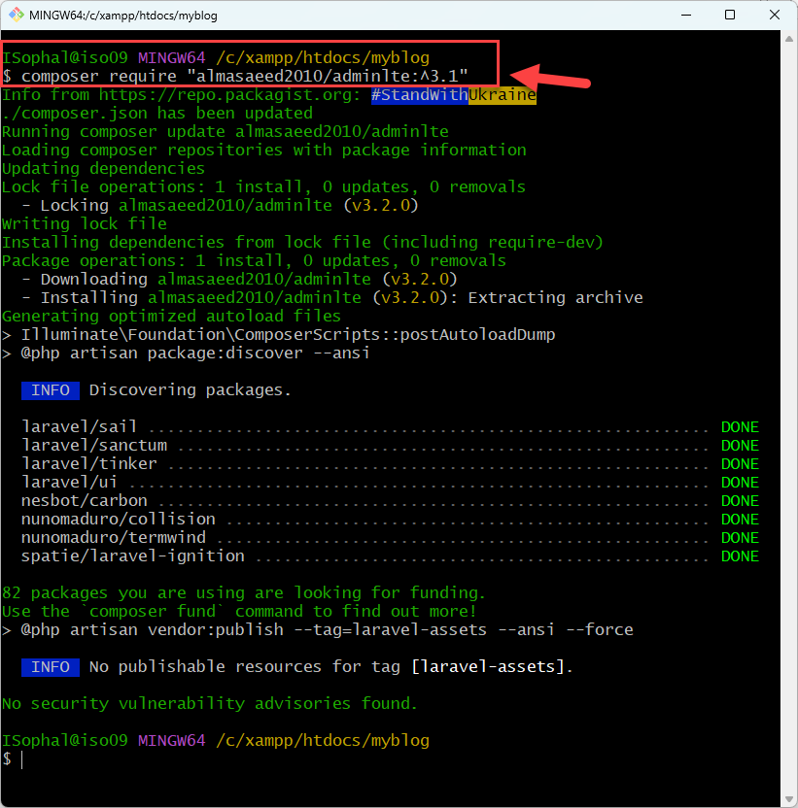

**composer require "almasaeed2010/adminlte:^3.1"**

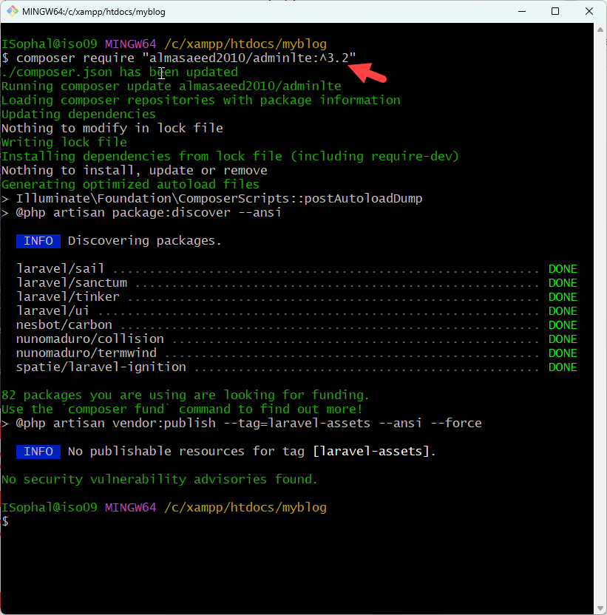

**composer require "almasaeed2010/adminlte:^3.2"**

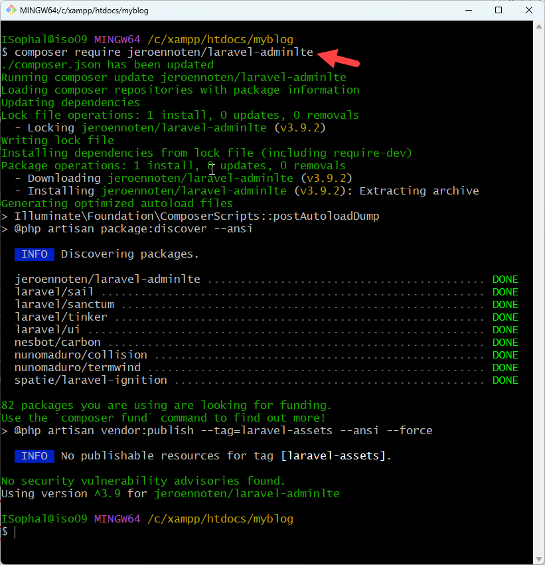

**composer require jeroennoten/laravel-adminlte**

**Step 2: Set up the Layout**

Create a Layout File:

how you can customize the AdminLTE layout file (layouts/app.blade.php)

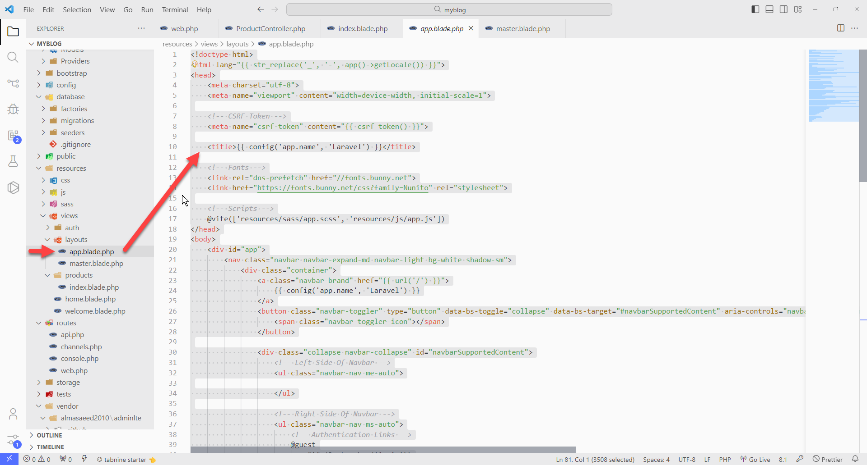

<!doctype html>

<html lang="{{ str_replace('_', '-', app()->getLocale()) }}">

<head>

    <meta charset="utf-8">

    <meta name="viewport" content="width=device-width, initial-scale=1">

*<!-- CSRF Token -->*

    <meta name="csrf-token" content="{{ csrf_token() }}">

    <title>{{ config('app.name', 'Laravel') }}</title>

*<!-- Fonts -->*

    <link rel="dns-prefetch" href="//fonts.bunny.net">

    <link href="https://fonts.bunny.net/css?family=Nunito" rel="stylesheet">

*<!-- Scripts -->*

    @vite(['resources/sass/app.scss', 'resources/js/app.js'])

</head>

<body>

    <div id="app">

        <nav class="navbar navbar-expand-md navbar-light bg-white shadow-sm">

            <div class="container">

                <a class="navbar-brand" href="{{ url('/') }}">

                    {{ config('app.name', 'Laravel') }}

                </a>

                <button class="navbar-toggler" type="button" data-bs-toggle="collapse" data-bs-target="#navbarSupportedContent" aria-controls="navbarSupportedContent" aria-expanded="false" aria-label="{{ __('Toggle navigation') }}">

                    <span class="navbar-toggler-icon"></span>

                </button>

                <div class="collapse navbar-collapse" id="navbarSupportedContent">

*<!-- Left Side Of Navbar -->*

                    <ul class="navbar-nav me-auto">

                    </ul>

*<!-- Right Side Of Navbar -->*

                    <ul class="navbar-nav ms-auto">

*<!-- Authentication Links -->*

                        @guest

                            @if (Route::has('login'))

                                <li class="nav-item">

                                    <a class="nav-link" href="{{ route('login') }}">{{ __('Login') }}</a>

                                </li>

                            @endif

                            @if (Route::has('register'))

                                <li class="nav-item">

                                    <a class="nav-link" href="{{ route('register') }}">{{ __('Register') }}</a>

                                </li>

                            @endif

                        @else

                            <li class="nav-item dropdown">

                                <a id="navbarDropdown" class="nav-link dropdown-toggle" href="#" role="button" data-bs-toggle="dropdown" aria-haspopup="true" aria-expanded="false" v-pre>

                                    {{ Auth::user()->name }}

                                </a>

                                <div class="dropdown-menu dropdown-menu-end" aria-labelledby="navbarDropdown">

                                    <a class="dropdown-item" href="{{ route('logout') }}"

                                       onclick="event.preventDefault();

                                                     document.getElementById('logout-form').submit();">

                                        {{ __('Logout') }}

                                    </a>

                                    <form id="logout-form" action="{{ route('logout') }}" method="POST" class="d-none">

                                        @csrf

                                    </form>

                                </div>

                            </li>

                        @endguest

                    </ul>

                </div>

            </div>

        </nav>

        <main class="py-4">

            @yield('content')

        </main>

    </div>

</body>

</html>

### Require the AdminLTE Package

Use Composer to require the AdminLTE package:

**composer require jeroennoten/laravel-adminlte**

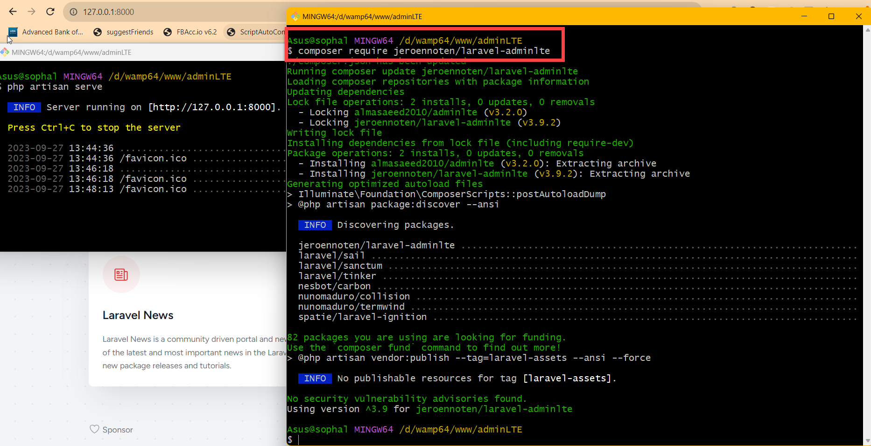

**Step 4: Publish the Assets and Configuration**

**php artisan adminlte:install**

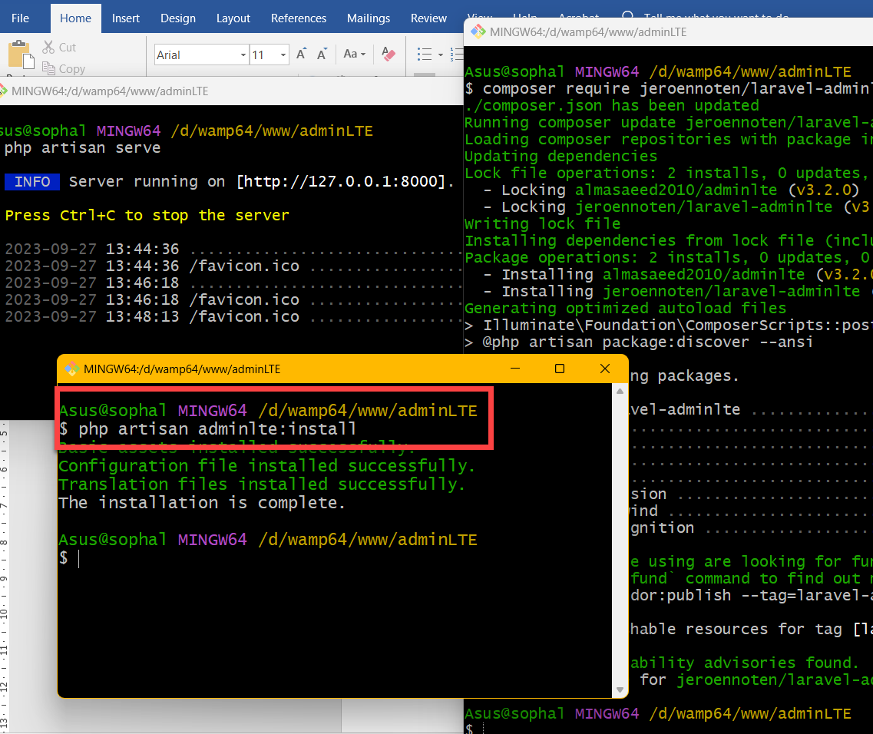

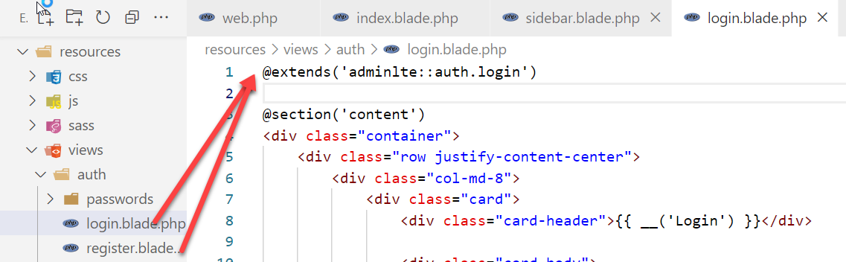

@extends('adminlte::auth.login')

@section('content')

………………………………………

………………………………………

………………………………………

@endsection

Result:

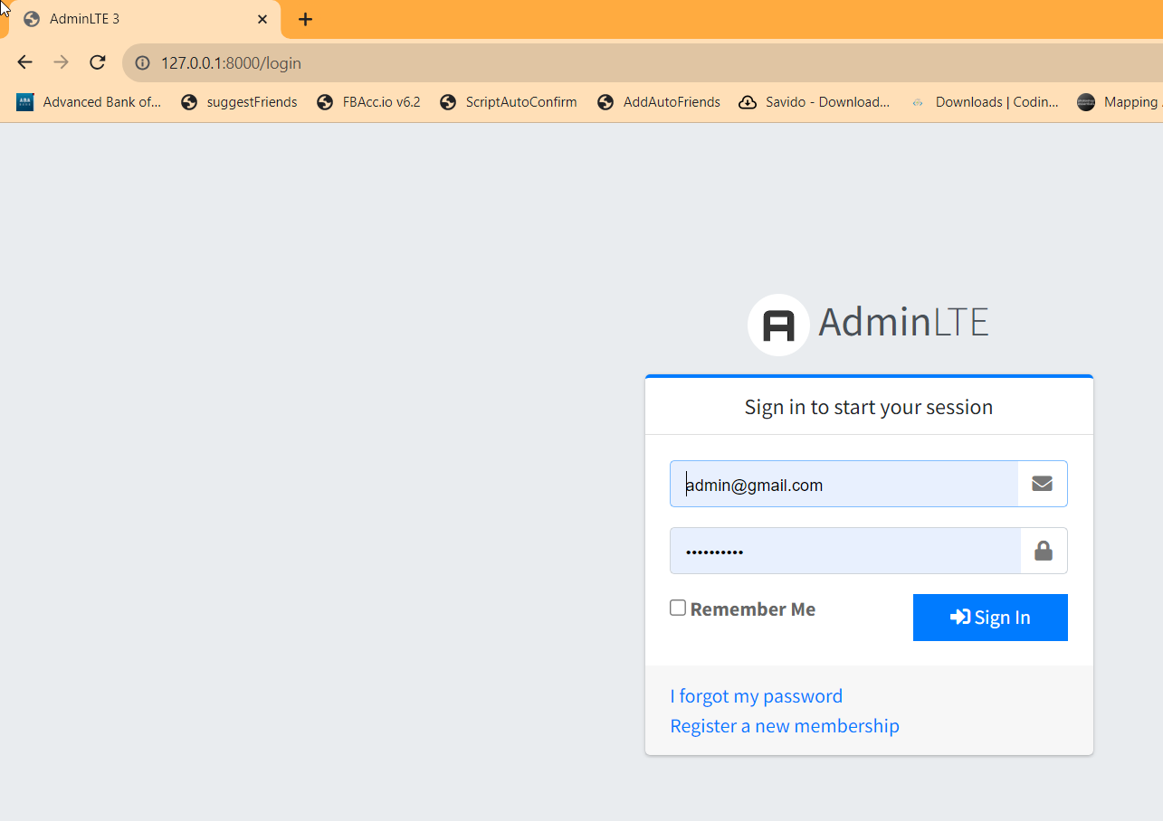

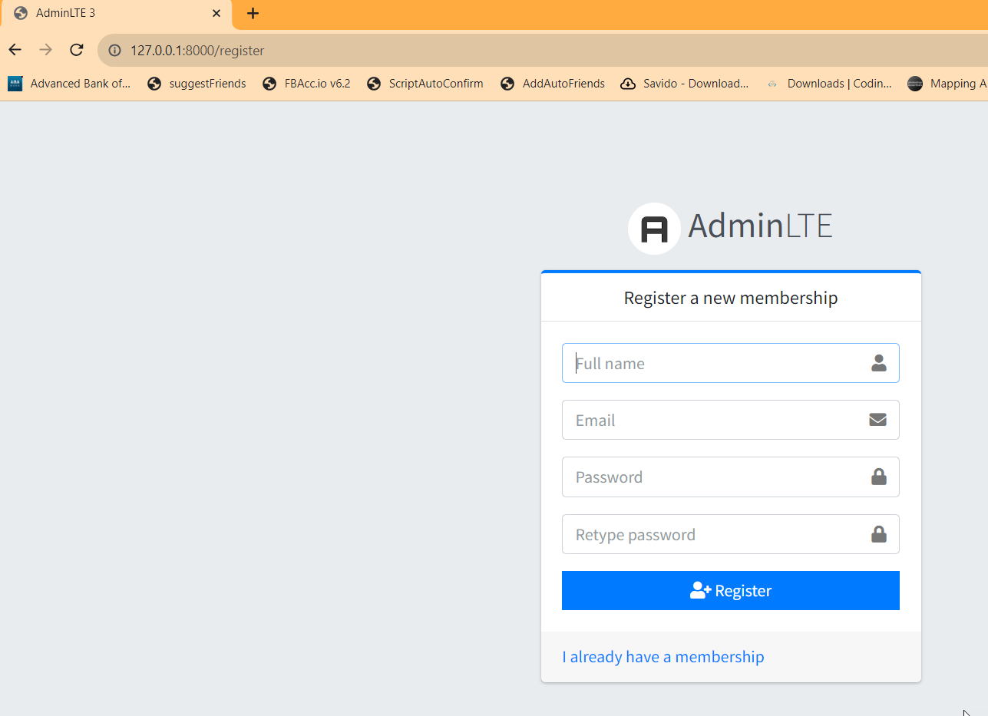

**OR**

**how you can customize the AdminLTE layout file (master.blade.php)**

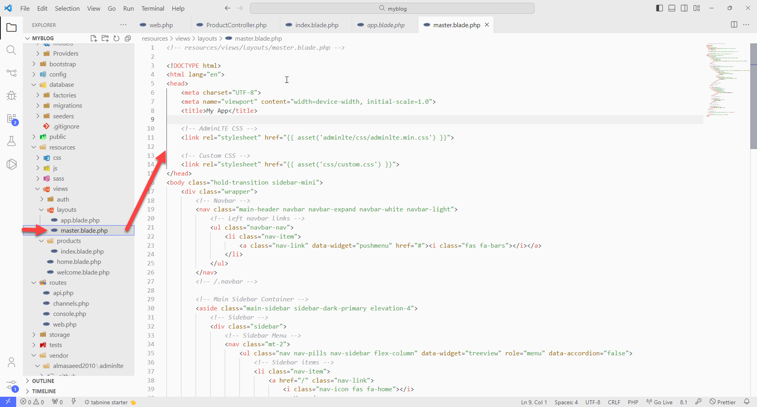

*<!-- resources/views/layouts/master.blade.php -->*

<!DOCTYPE html>

<html lang="en">

<head>

    <meta charset="UTF-8">

    <meta name="viewport" content="width=device-width, initial-scale=1.0">

    <title>My App</title>

*<!-- AdminLTE CSS -->*

    <link rel="stylesheet" href="{{ asset('adminlte/css/adminlte.min.css') }}">

*<!-- Custom CSS -->*

    <link rel="stylesheet" href="{{ asset('css/custom.css') }}">

</head>

<body class="hold-transition sidebar-mini">

    <div class="wrapper">

*<!-- Navbar -->*

        <nav class="main-header navbar navbar-expand navbar-white navbar-light">

*<!-- Left navbar links -->*

            <ul class="navbar-nav">

                <li class="nav-item">

                    <a class="nav-link" data-widget="pushmenu" href="#"><i class="fas fa-bars"></i></a>

                </li>

            </ul>

        </nav>

*<!-- /.navbar -->*

*<!-- Main Sidebar Container -->*

        <aside class="main-sidebar sidebar-dark-primary elevation-4">

*<!-- Sidebar -->*

            <div class="sidebar">

*<!-- Sidebar Menu -->*

                <nav class="mt-2">

                    <ul class="nav nav-pills nav-sidebar flex-column" data-widget="treeview" role="menu" data-accordion="false">

*<!-- Sidebar items -->*

                        <li class="nav-item">

                            <a href="/" class="nav-link">

                                <i class="nav-icon fas fa-home"></i>

                                <p>Home</p>

                            </a>

                        </li>

                        <li class="nav-item">

                            <a href="/products" class="nav-link">

                                <i class="nav-icon fas fa-shopping-cart"></i>

                                <p>Products</p>

                            </a>

                        </li>

                    </ul>

                </nav>

*<!-- /.sidebar-menu -->*

            </div>

*<!-- /.sidebar -->*

        </aside>

*<!-- Content Wrapper -->*

        <div class="content-wrapper">

*<!-- Content Header (Page header) -->*

            <div class="content-header">

                <div class="container-fluid">

                    <div class="row mb-2">

                        <div class="col-sm-6">

                            <h1 class="m-0">Product Management</h1>

                        </div>

                    </div>

                </div>

            </div>

*<!-- /.content-header -->*

*<!-- Main content -->*

            <div class="content">

                <div class="container-fluid">

                    @yield('content')

                </div>

            </div>

*<!-- /.content -->*

        </div>

*<!-- /.content-wrapper -->*

*<!-- Main Footer -->*

        <footer class="main-footer">

            <strong>My App &copy; 2023</strong>

        </footer>

    </div>

*<!-- ./wrapper -->*

*<!-- AdminLTE JS -->*

    <script src="{{ asset('adminlte/js/adminlte.min.js') }}"></script>

*<!-- Custom JS -->*

    <script src="{{ asset('js/custom.js') }}"></script>

</body>

</html>

**Step 3: Create the "Products" Views**

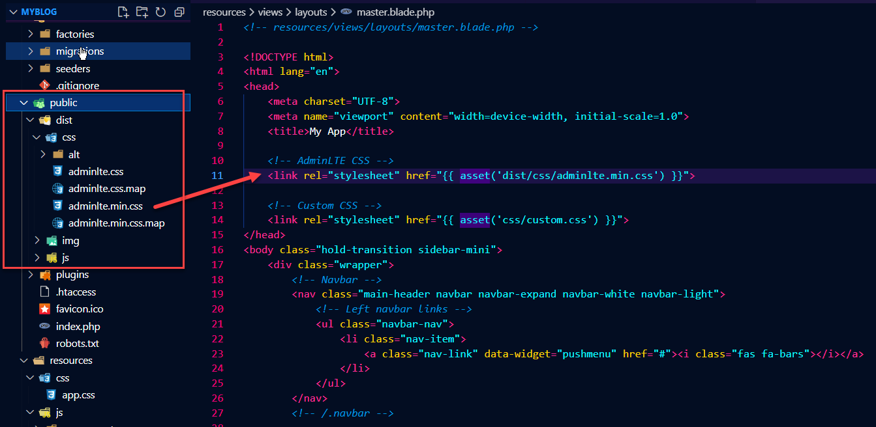

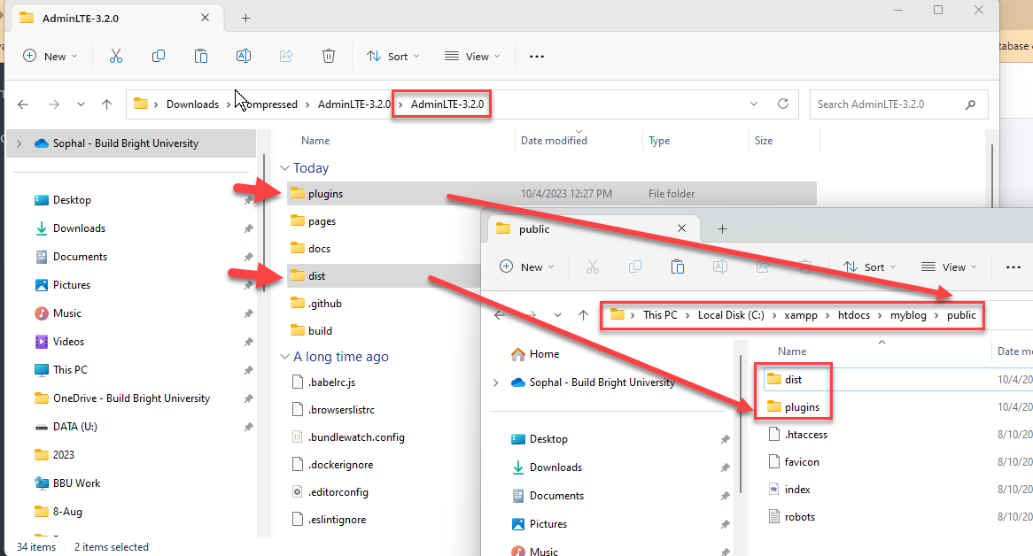

create a view for displaying a list of products (index.blade.php):

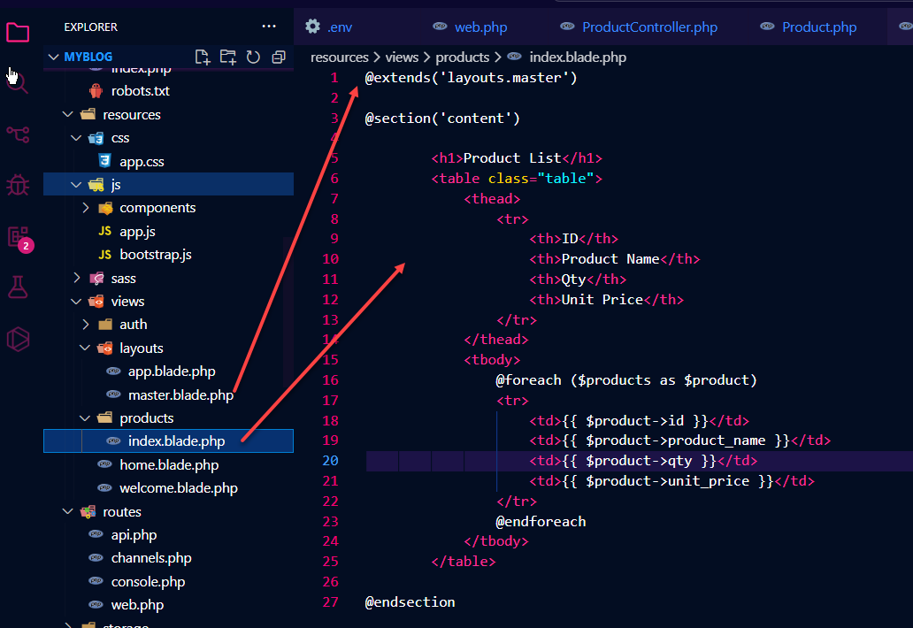

@extends('layouts.master')

@section('content')

        <h1>Product List</h1>

        <table class="table">

            <thead>

                <tr>

                    <th>ID</th>

                    <th>Product Name</th>

                    <th>Qty</th>

                    <th>Unit Price</th>

                </tr>

            </thead>

            <tbody>

                @foreach ($products as $product)

                <tr>

                    <td>{{ $product->id }}</td>

                    <td>{{ $product->product_name }}</td>

                    <td>{{ $product->qty }}</td>

                    <td>{{ $product->unit_price }}</td>

                </tr>

                @endforeach

            </tbody>

        </table>

@endsection

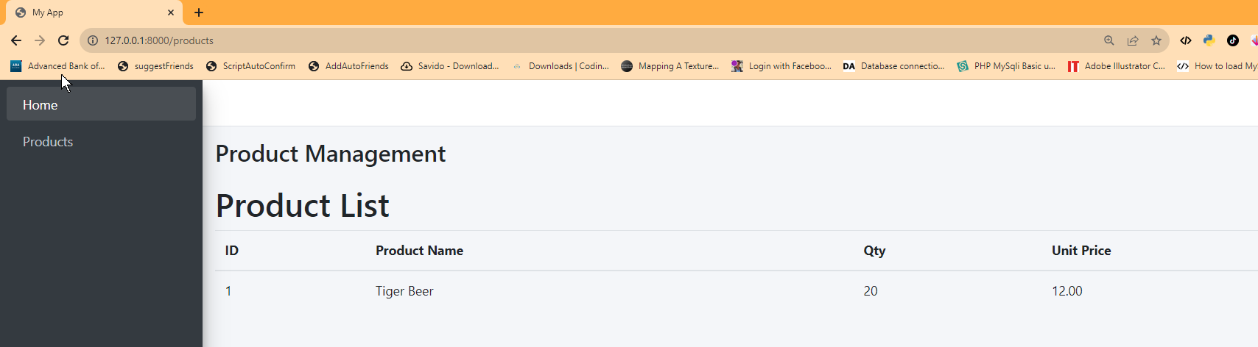

### Model: Product.php

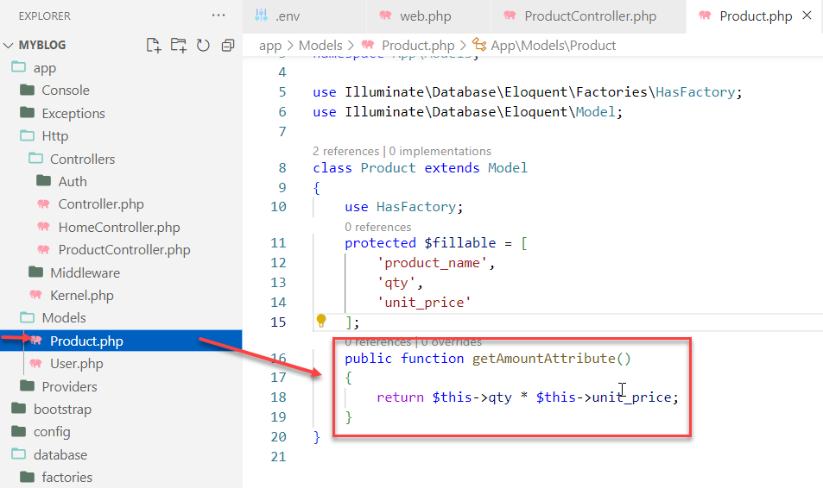

    public function getAmountAttribute()

    {

        return $this->qty * $this->unit_price;

    }

**Views**

For the **Amount** column

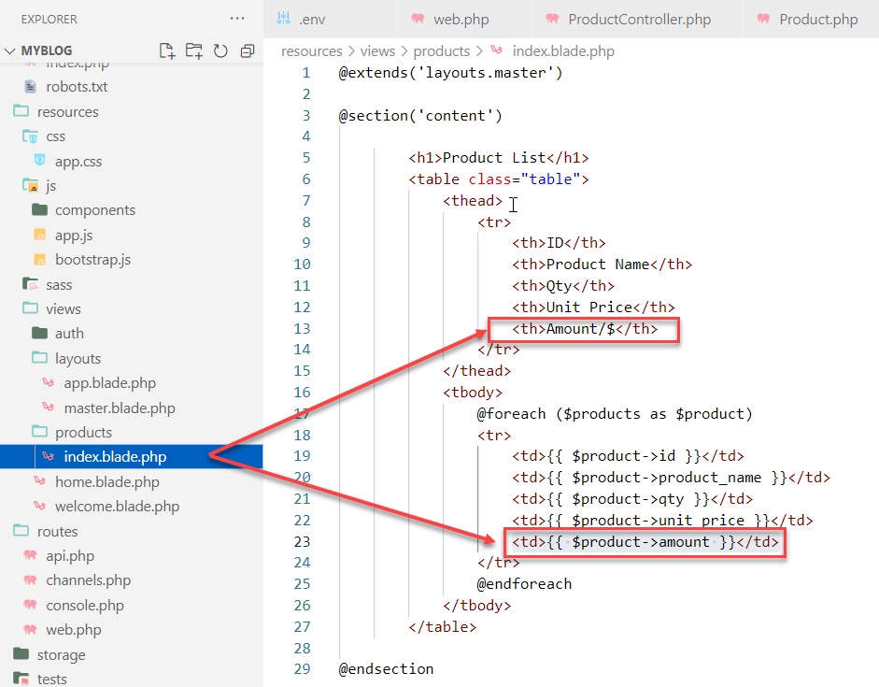

Add Sub-Total:

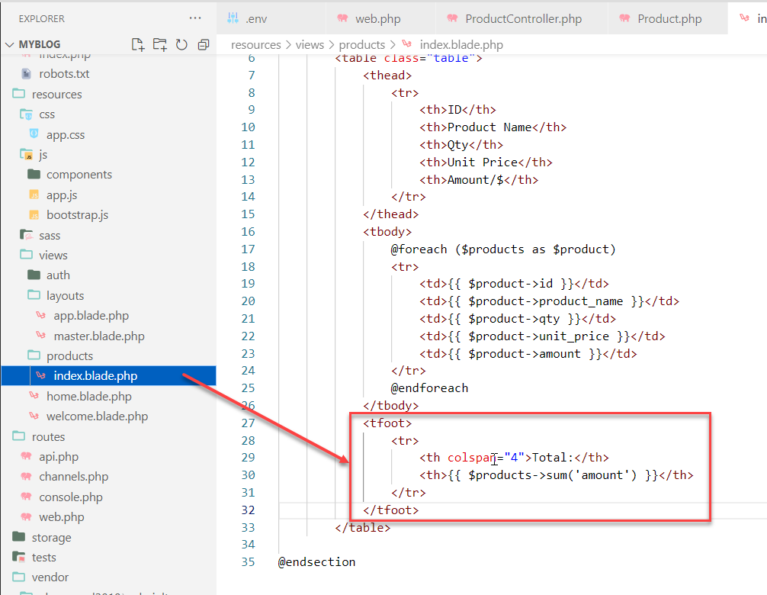

            <tfoot>

                <tr>

                    <th colspan="4">Total:</th>

                    <th>{{ $products->sum('amount') }}</th>

                </tr>

            </tfoot>

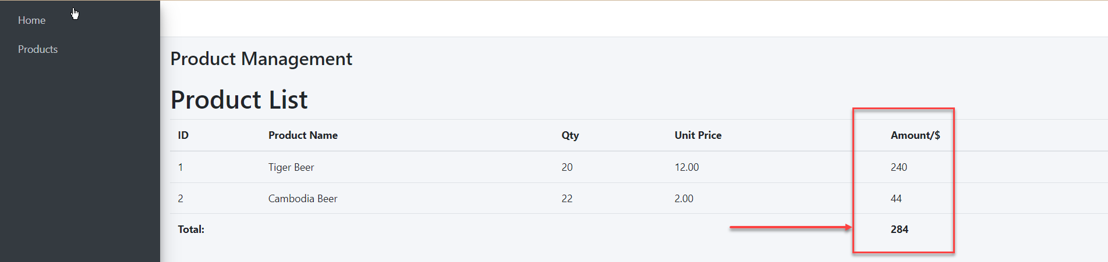

Step 4: Set up the Routes

Route::get('/products', [ProductController::class, 'index']);

**Step 6: Customize the Views**

create a view for creating a new product (create.blade.php)

#### resources/views/products/create.blade.php

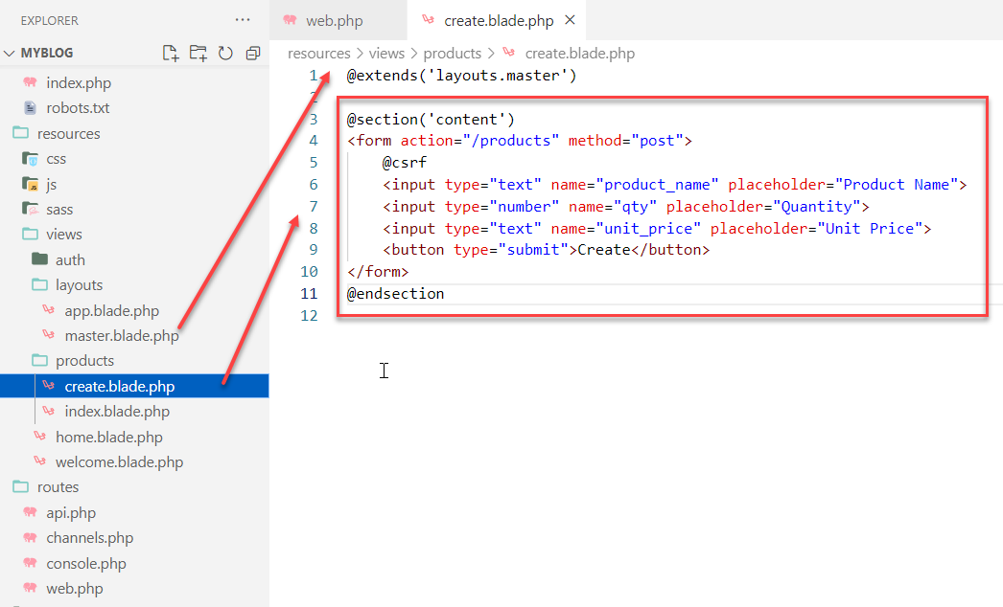

@extends('layouts.master')

@section('content')

<form action="/products" method="post">

    @csrf

    <input type="text" name="product_name" placeholder="Product Name">

    <input type="number" name="qty" placeholder="Quantity">

    <input type="text" name="unit_price" placeholder="Unit Price">

    <button type="submit">Create</button>

</form>

@endsection

**Step 6.1: Customize the Route**

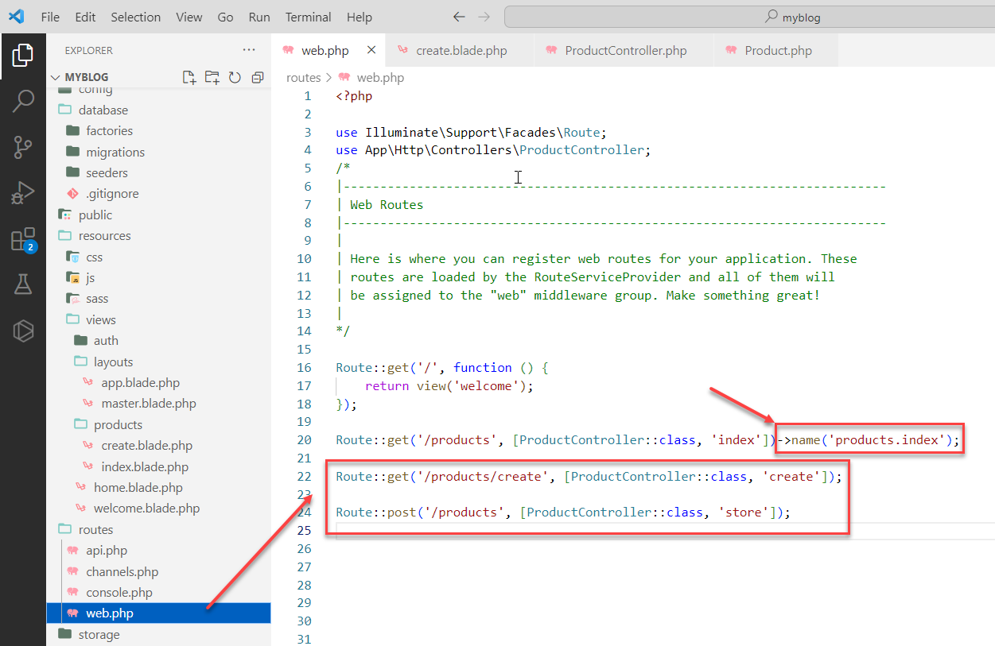

**Step 6.2: Customize the Controller**

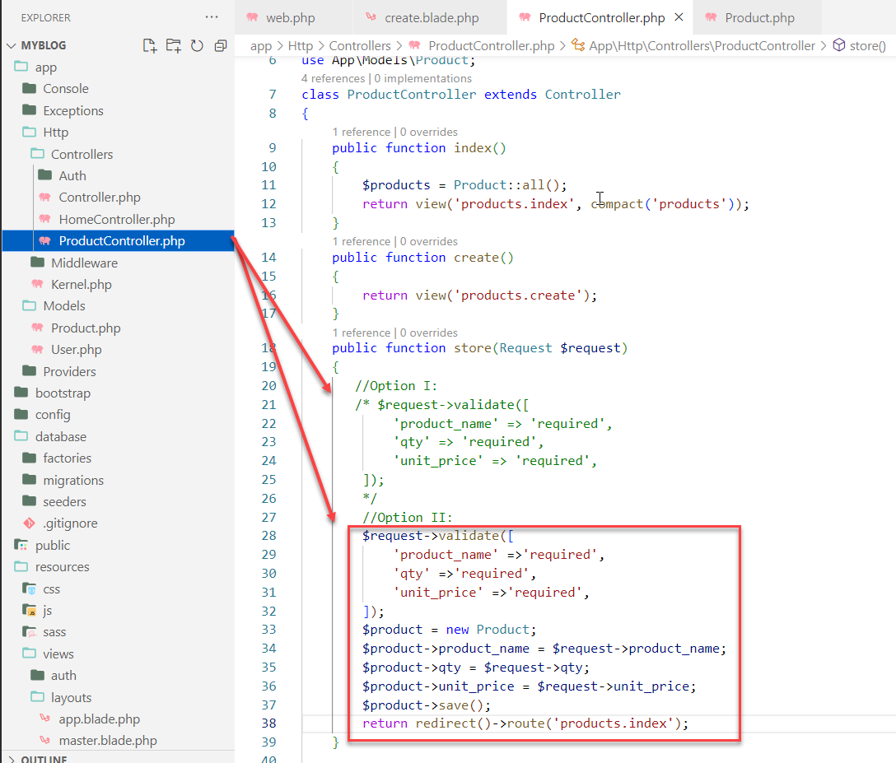

public function store(Request $request)

{

//Option I:

        $request->validate([

            'product_name' => 'required',

            'qty' => 'required',

            'unit_price' => 'required',

        ]);

**}**

**Update:**

public function store(Request $request)

{

//Option II:

        $request->validate([

            'product_name' =>'required',

            'qty' =>'required',

            'unit_price' =>'required',

        ]);

        $product = new Product;

        $product->product_name = $request->product_name;

        $product->qty = $request->qty;

        $product->unit_price = $request->unit_price;

        $product->save();

        return redirect()->route('products.index');

}

**Result:**

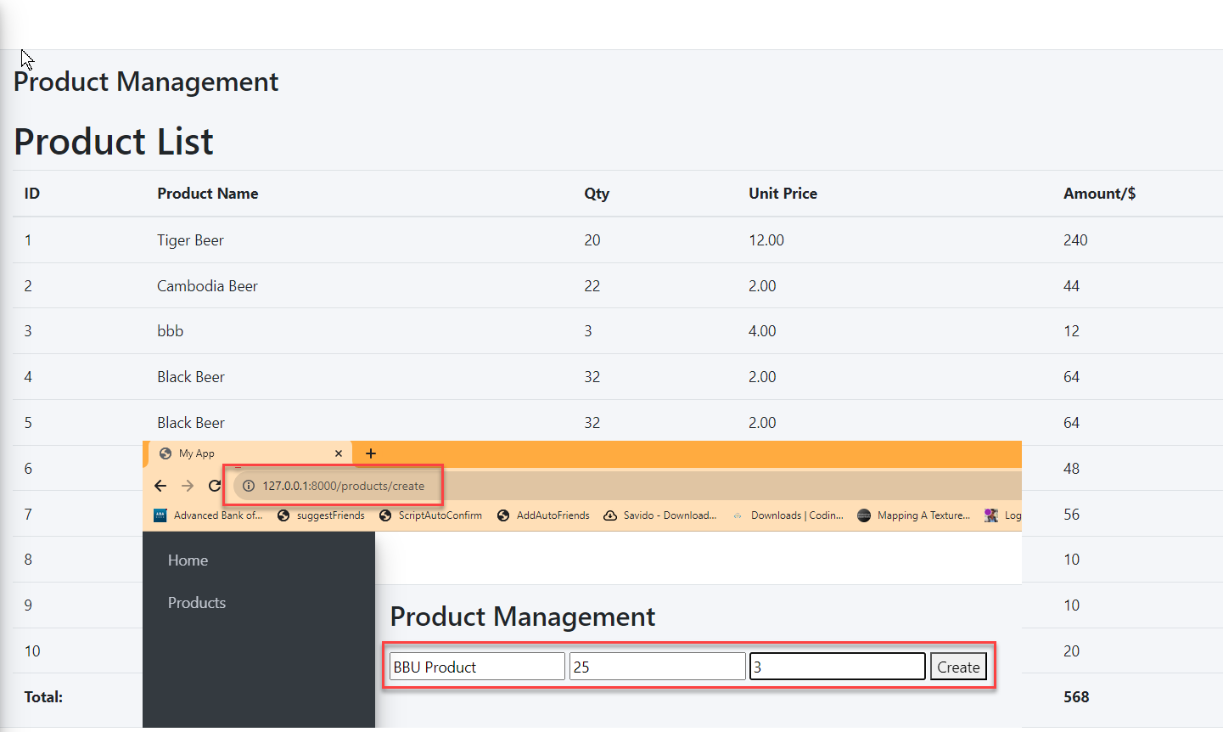

**Update View:**

Integrate AdminLTE into a **create.blade.php** view file

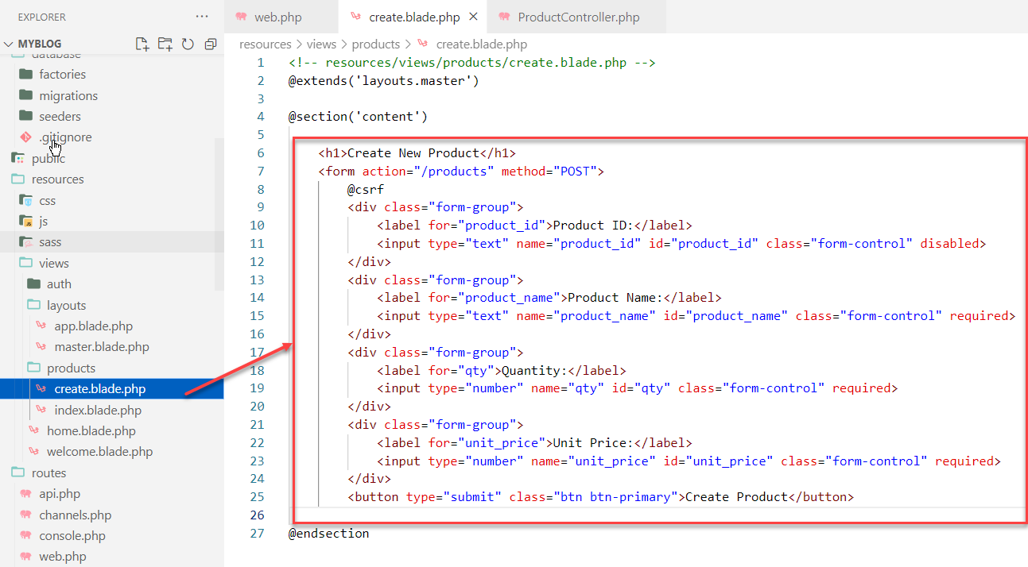

<!-- resources/views/products/create.blade.php -->

@extends('layouts.master')

@section('content')

    <h1>Create New Product</h1>

    <form action="/products" method="POST">

        @csrf

        <div class="form-group">

            <label for="product_id">Product ID:</label>

            <input type="text" name="product_id" id="product_id" class="form-control" disabled>

        </div>

        <div class="form-group">

            <label for="product_name">Product Name:</label>

            <input type="text" name="product_name" id="product_name" class="form-control" required>

        </div>

        <div class="form-group">

            <label for="qty">Quantity:</label>

            <input type="number" name="qty" id="qty" class="form-control" required>

        </div>

        <div class="form-group">

            <label for="unit_price">Unit Price:</label>

            <input type="number" name="unit_price" id="unit_price" class="form-control" required>

        </div>

        <button type="submit" class="btn btn-primary">Create Product</button>

@endsection

 To create a view for displaying the details of a single product (show.blade.php)

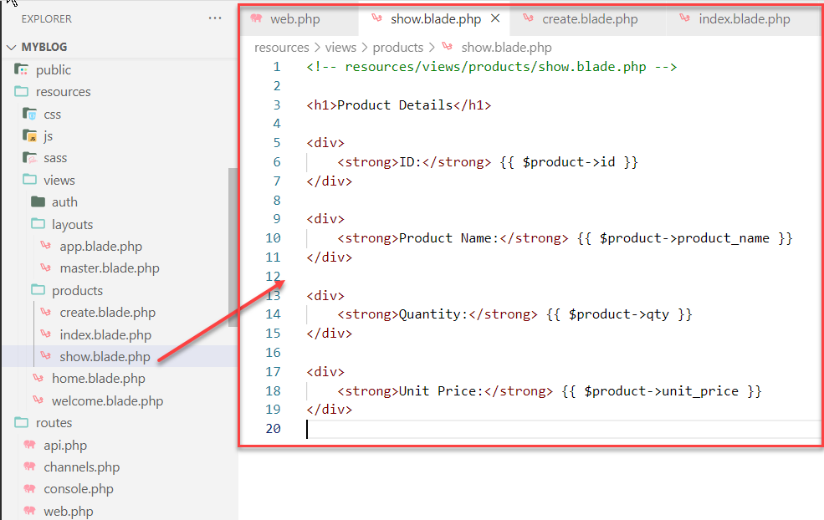

<!-- resources/views/products/show.blade.php -->

<h1>Product Details</h1>

<div>

    <strong>ID:</strong> {{ $product->id }}

</div>

<div>

    <strong>Product Name:</strong> {{ $product->product_name }}

</div>

<div>

    <strong>Quantity:</strong> {{ $product->qty }}

</div>

<div>

    <strong>Unit Price:</strong> {{ $product->unit_price }}

</div>

#### resources/views/products/index.blade.php

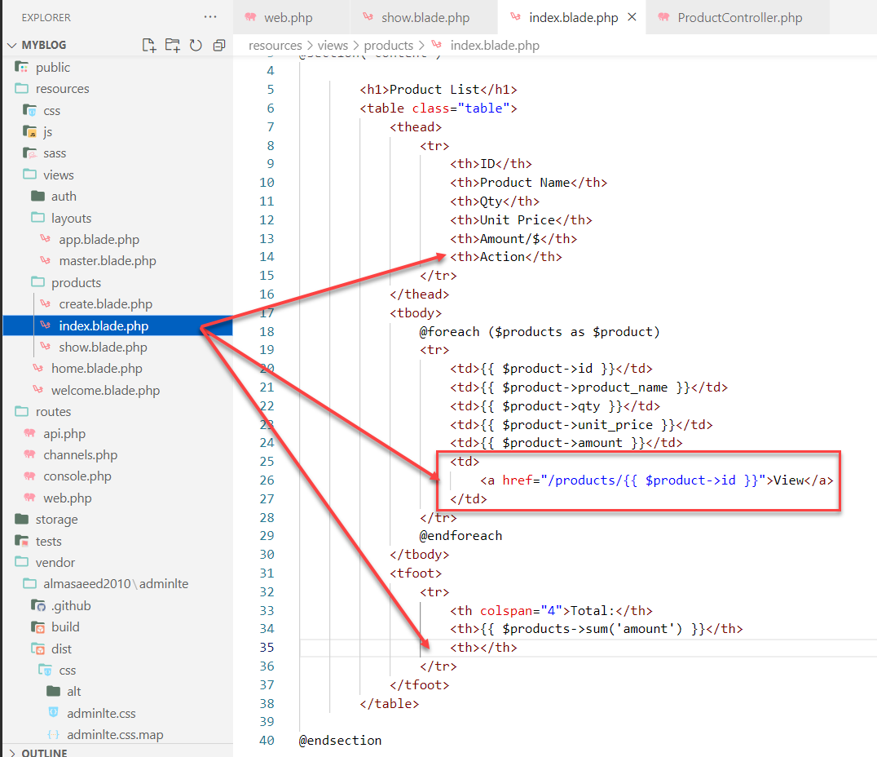

   <td>

       <a href="/products/{{ $product->id }}">View</a>

   </td>

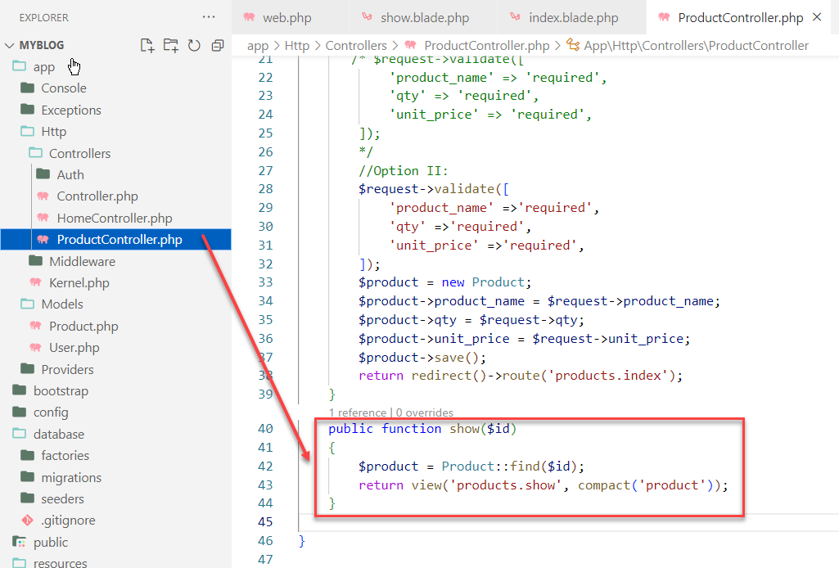

**Customer the Product Controller**

Open the app/Http/Controllers/ProductController.php

    public function show($id)

    {

        $product = Product::find($id);

        return view('products.show', compact('product'));

    }

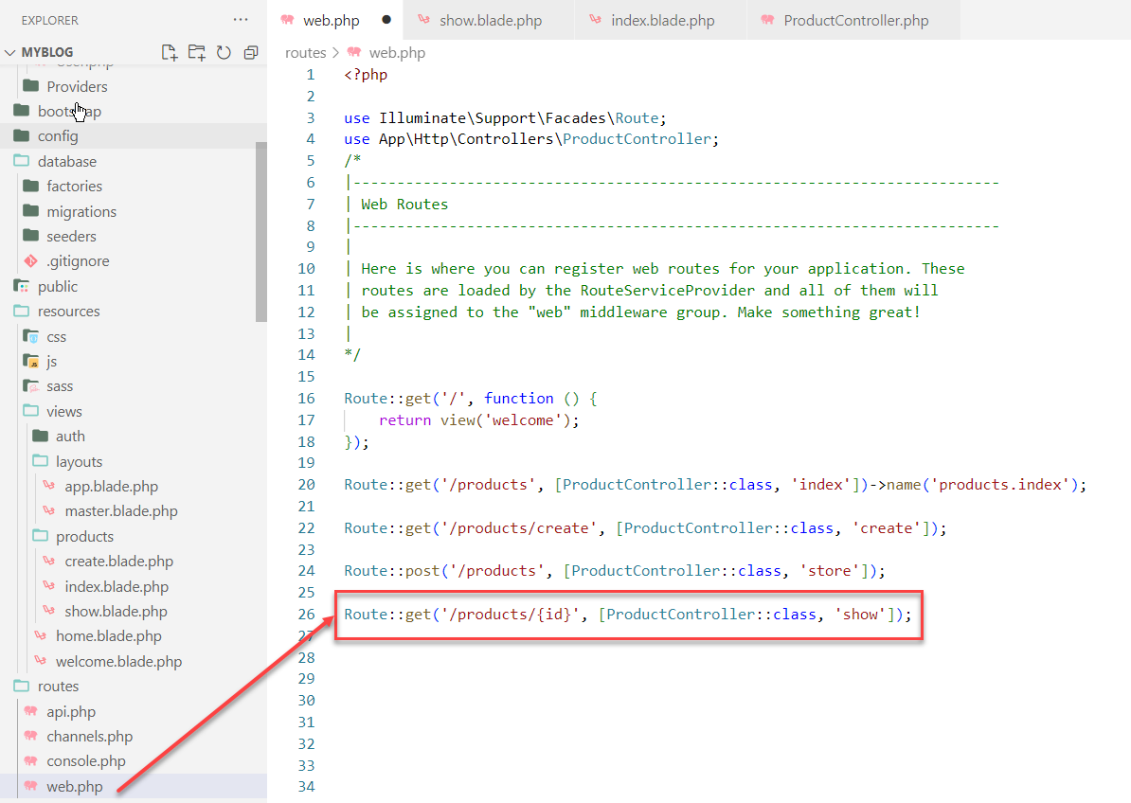

Route::get('/products/{id}', [ProductController::class, 'show']);

Update View:

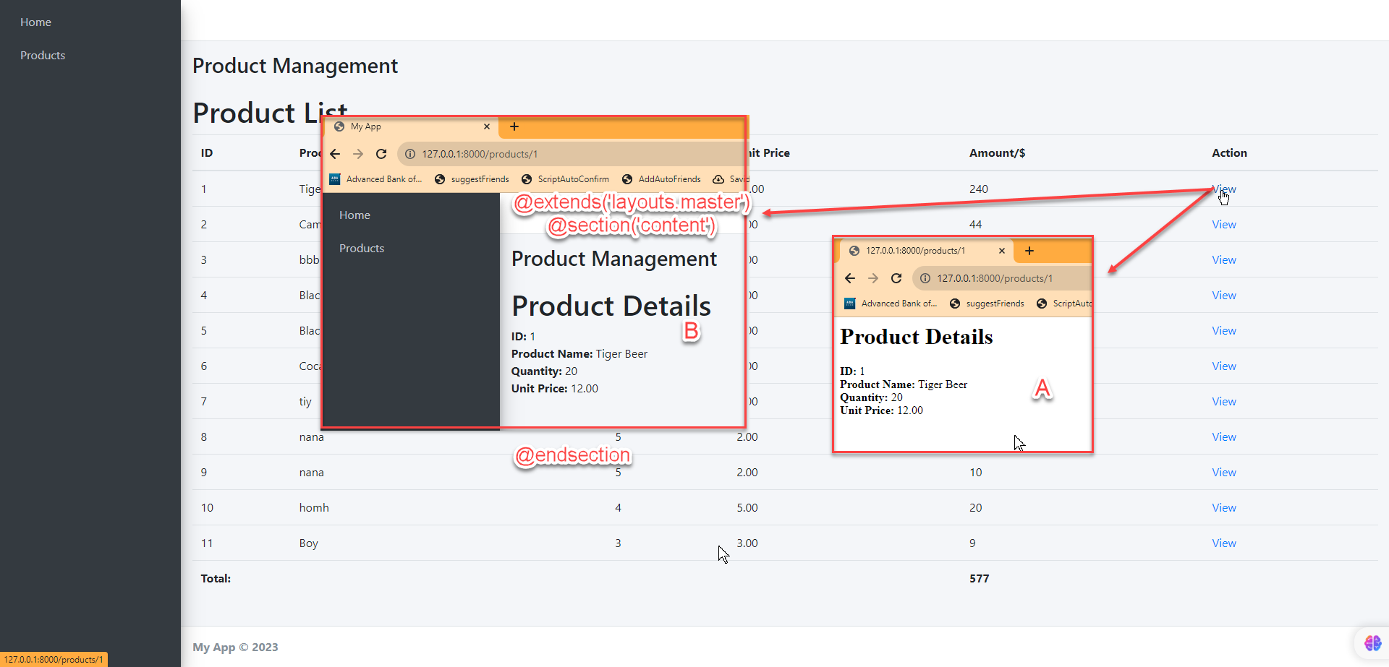

<!-- resources/views/products/show.blade.php -->

@extends('layouts.master')

@section('content')

    <h1>Product Details</h1>

    <div>

        <strong>ID:</strong> {{ $product->id }}

    </div>

    <div>

        <strong>Product Name:</strong> {{ $product->product_name }}

    </div>

    <div>

        <strong>Quantity:</strong> {{ $product->qty }}

    </div>

    <div>

        <strong>Unit Price:</strong> {{ $product->unit_price }}

</div>

@endsection

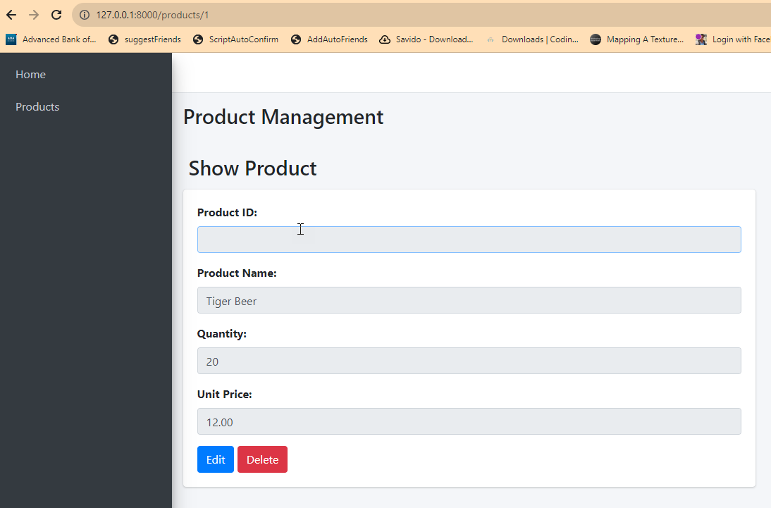

@extends('layouts.master')

@section('content')

        <div class="content-header">

                <h1>Show Product</h1>

        </div>

        <div class="row">

            <div class="col-md-6">

                <div class="card">

                    <div class="card-body">

                        <div class="form-group">

                            <label for="product_id">Product ID:</label>

                            <input type="text" id="product_id" class="form-control" value="{{ $product->product_id }}" readonly>

                        </div>

                        <div class="form-group">

                            <label for="product_name">Product Name:</label>

                            <input type="text" id="product_name" class="form-control" value="{{ $product->product_name }}" readonly>

                        </div>

                        <div class="form-group">

                            <label for="qty">Quantity:</label>

                            <input type="text" id="qty" class="form-control" value="{{ $product->qty }}" readonly>

                        </div>

                        <div class="form-group">

                            <label for="unit_price">Unit Price:</label>

                            <input type="text" id="unit_price" class="form-control" value="{{ $product->unit_price }}" readonly>

                        </div>

                        <div>

                            <a href="#" class="btn btn-primary">Edit</a>

                            <form action="#" method="POST" style="display: inline-block">

                                @csrf

                                @method('DELETE')

                                <button type="submit" class="btn btn-danger">Delete</button>

                            </form>

                        </div>

                    </div>

                </div>

            </div>

        </div>

@endsection

1. Open your show.blade.php file and update it with the following code:

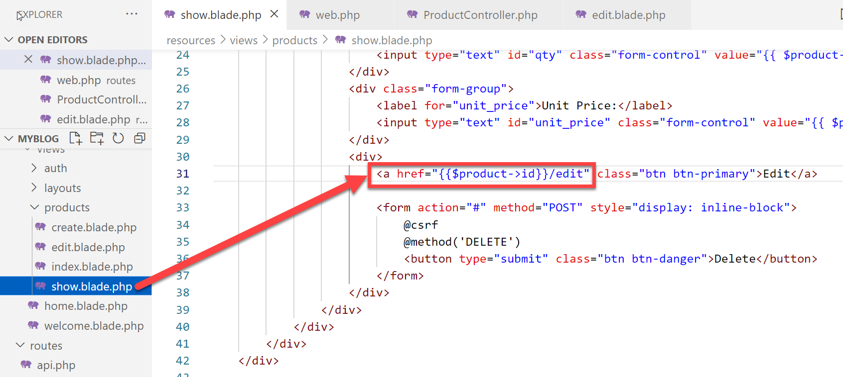

<a href="/products" class="btn btn-warning">Go Back</a>

<a href="{{$product->id}}/edit" class="btn btn-primary">Edit</a>

**Create a view for editing an existing product (edit.blade.php):**

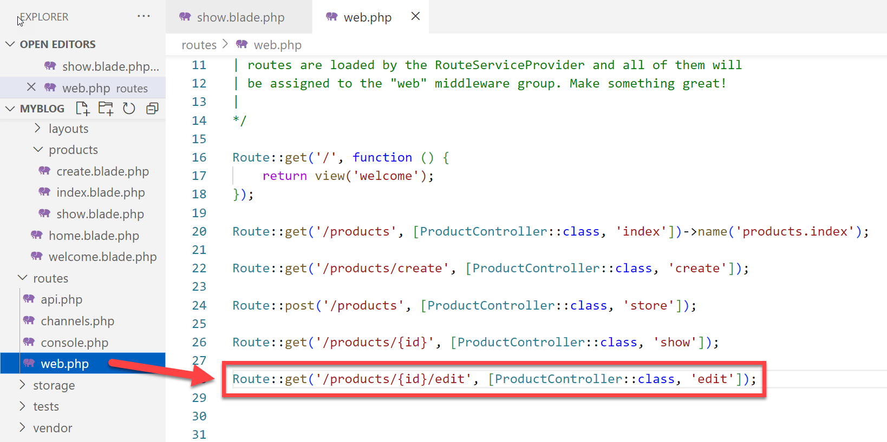

Route::get('/products/{id}/edit', [ProductController::class, 'edit']);

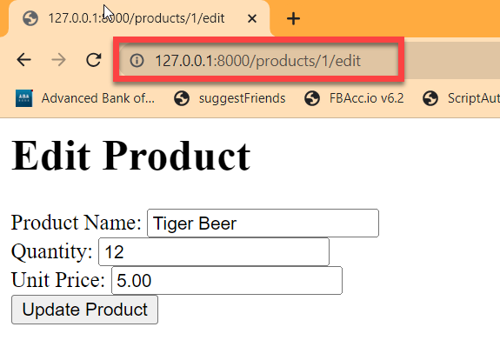

<!-- resources/views/products/edit.blade.php -->

<h1>Edit Product</h1>

<form action="/products/{{ $product->id }}" method="POST">

    @csrf

    @method('PUT')

    <div>

        <label for="product_name">Product Name:</label>

        <input type="text" id="product_name" name="product_name" value="{{ old('product_name', $product->product_name) }}">

    </div>

    <div>

        <label for="qty">Quantity:</label>

        <input type="number" id="qty" name="qty" value="{{ old('qty', $product->qty) }}">

    </div>

    <div>

        <label for="unit_price">Unit Price:</label>

        <input type="number" step="0.01" id="unit_price" name="unit_price" value="{{ old('unit_price', $product->unit_price) }}">

    </div>

    <button type="submit">Update Product</button>

</form>

**Update** To integrate AdminLTE into the **edit.blade.php**

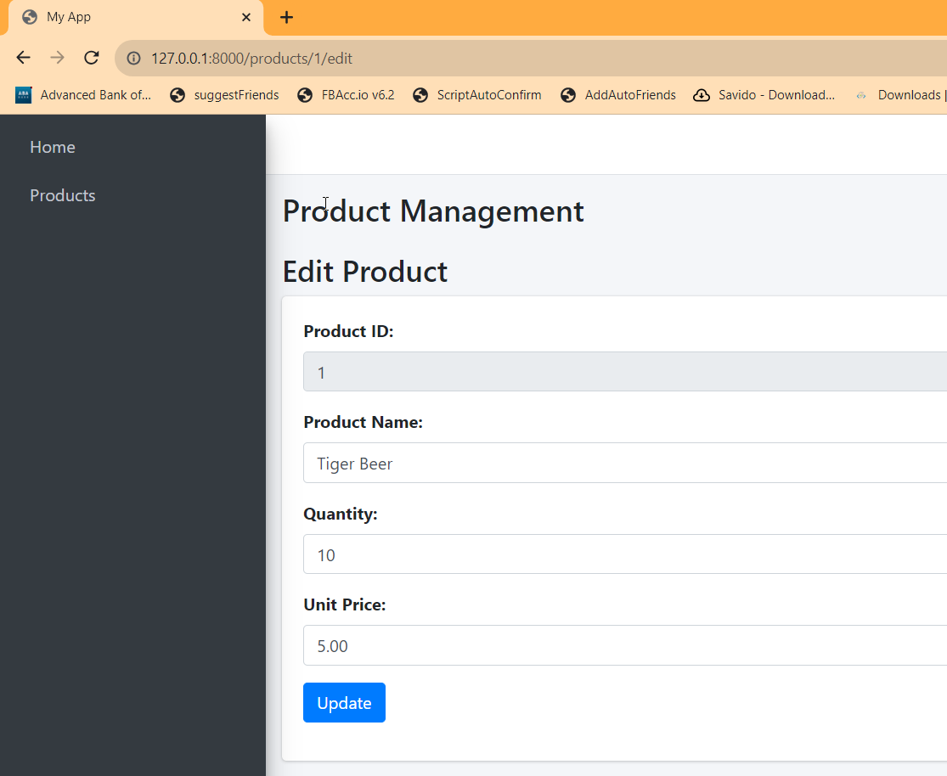

<!-- resources/views/products/edit.blade.php -->

@extends('layouts.master')

@section('content')

    <h3>Edit Product</h3>

    <div class="card">

        <div class="card-body">

            <form action="/products/{{ $product->id }}"  method="POST">

                @csrf

                @method('PUT')

                <div class="form-group">

                    <label for="product_id">Product ID:</label>

                    <input type="text" id="product_id" class="form-control" name="product_id" value="{{ $product->id }}" disabled>

                </div>

                <div class="form-group">

                    <label for="product_name">Product Name:</label>

                    <input type="text" id="product_name" class="form-control" name="product_name" value="{{ $product->product_name }}" required>

                </div>

                <div class="form-group">

                    <label for="qty">Quantity:</label>

                    <input type="text" id="qty" class="form-control" name="qty" value="{{ $product->qty }}" required>

                </div>

                <div class="form-group">

                    <label for="unit_price">Unit Price:</label>

                    <input type="text" id="unit_price" class="form-control" name="unit_price" value="{{ $product->unit_price }}" required>

                </div>

                <div class="form-group">

                    <button type="submit" class="btn btn-primary">Update</button>

                </div>

            </form>

        </div>

    </div>

@endsection

Update : Controller

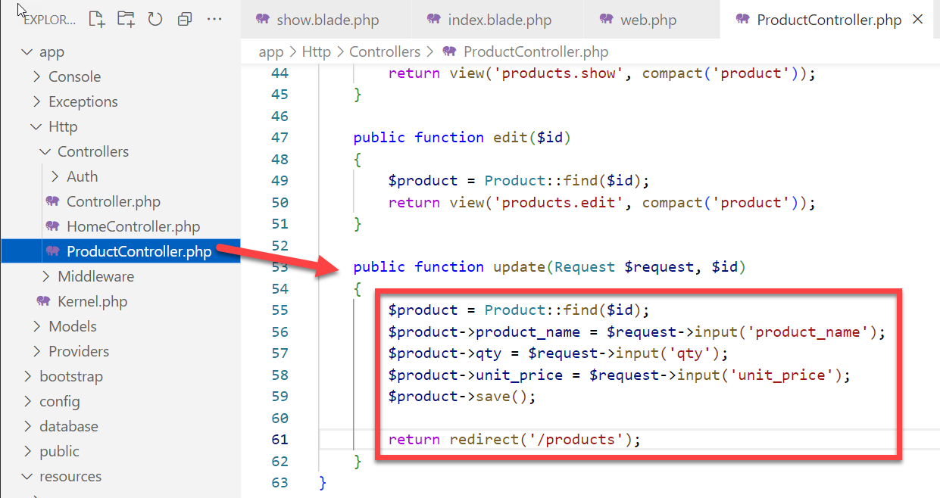

    public function update(Request $request, $id)

    {

        $product = Product::find($id);

        $product->product_name = $request->input('product_name');

        $product->qty = $request->input('qty');

        $product->unit_price = $request->input('unit_price');

        $product->save();

        return redirect('/products');

    }

Update : web.php

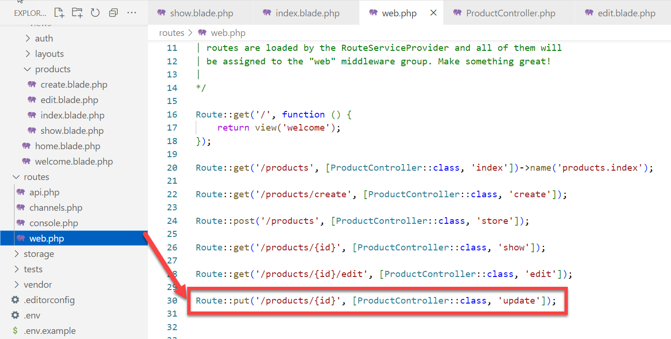

Route::put('/products/{id}', [ProductController::class, 'update']);

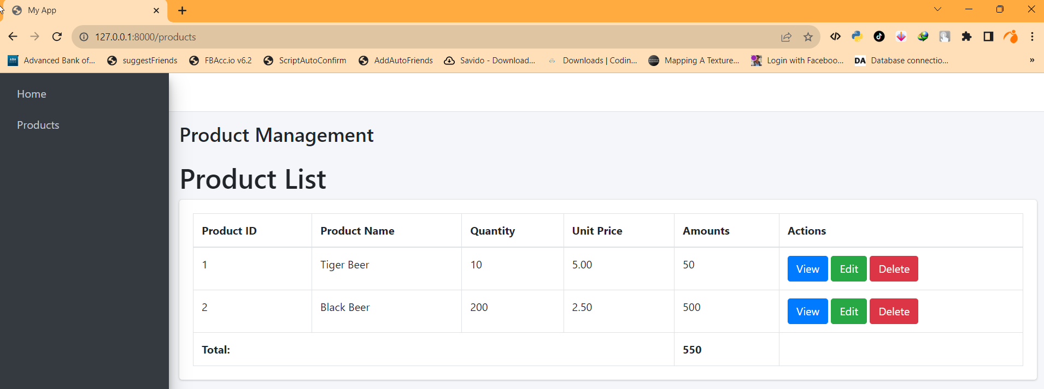

  <a href="/products/{{ $product->id }}" class="btn btn-primary">View</a>

  <a href="/products/{{ $product->id }}/edit" class="btn btn-success">Edit</a>

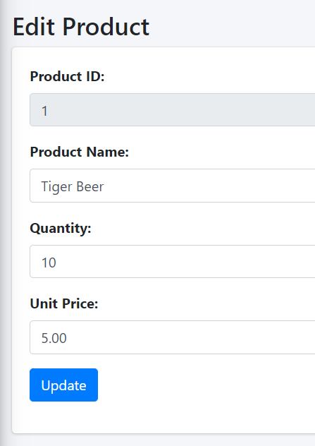

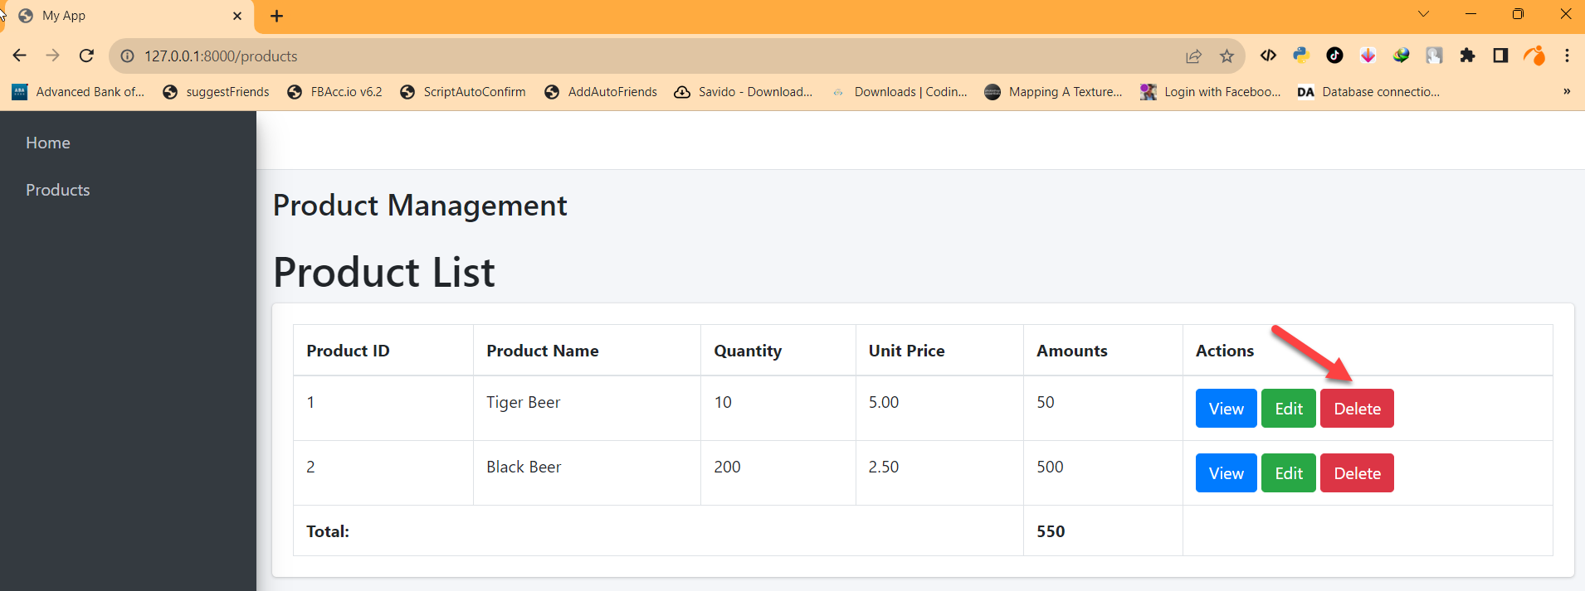

<form action="/products/{{ $product->id }}" method="POST" style="display: inline-block">

 @csrf

 @method('DELETE')

 <button type="submit" class="btn btn-danger">Delete</button>

</form>

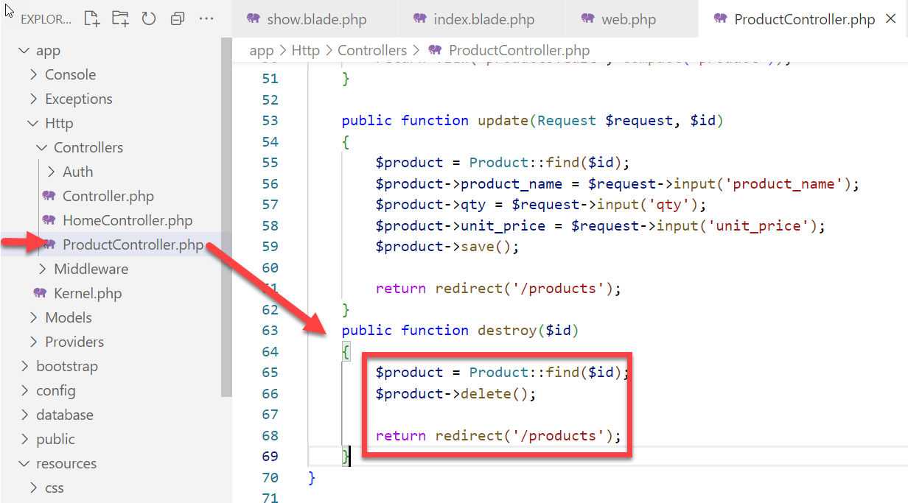

    public function destroy($id)

    {

        $product = Product::find($id);

        $product->delete();

        return redirect('/products');

    }

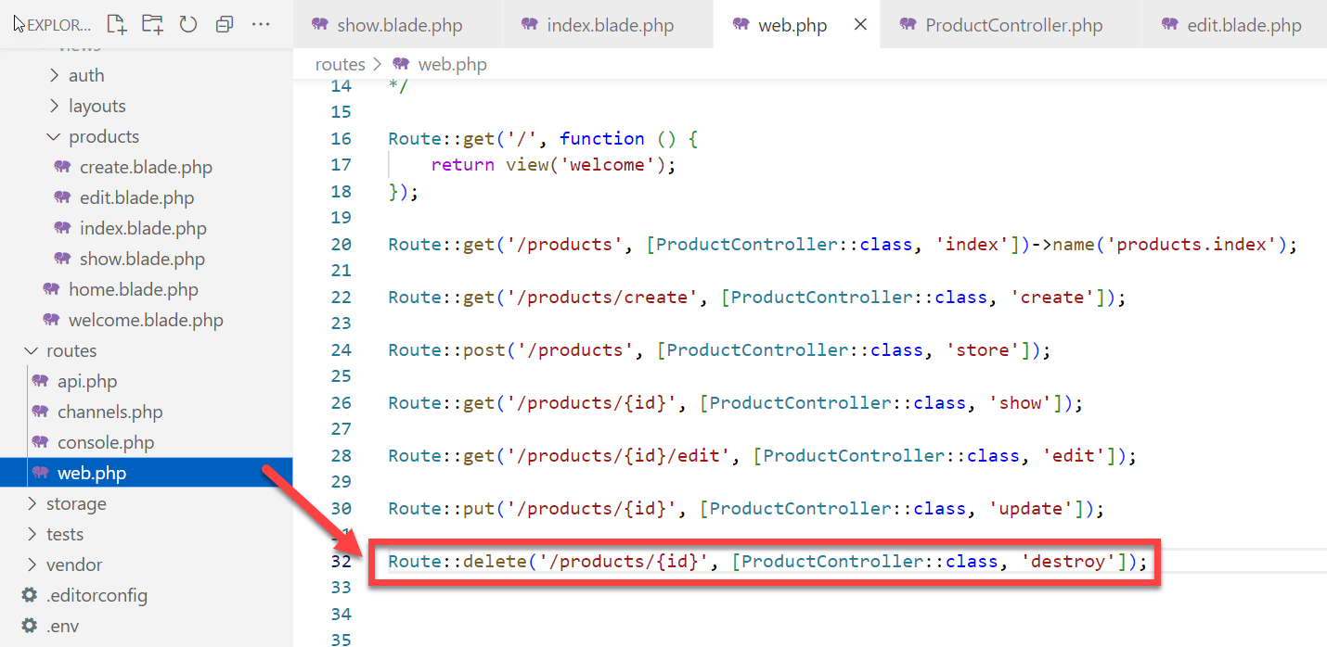

Route::delete('/products/{id}', [ProductController::class, 'destroy']);

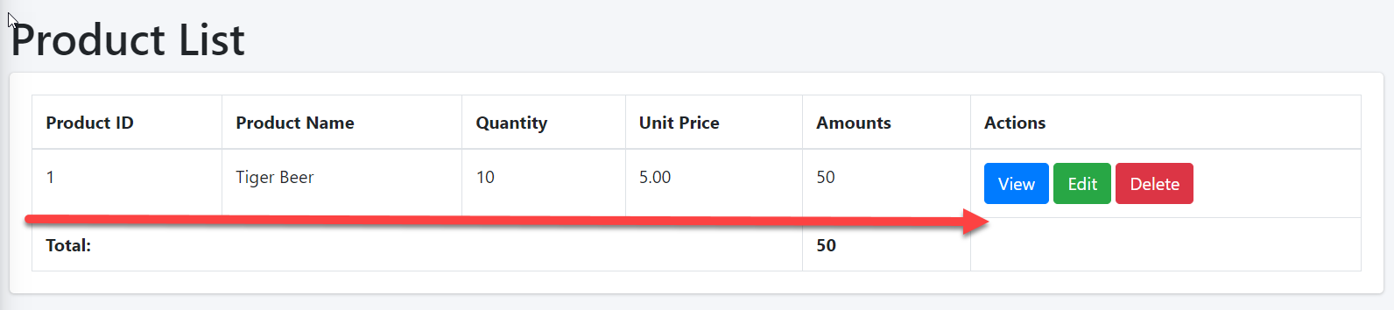

**Part B….**

**To Be Continue ……**

### Adding Controller and Routing

We are ready to create our Controller by running

**php artisan make:controller Products –resource**

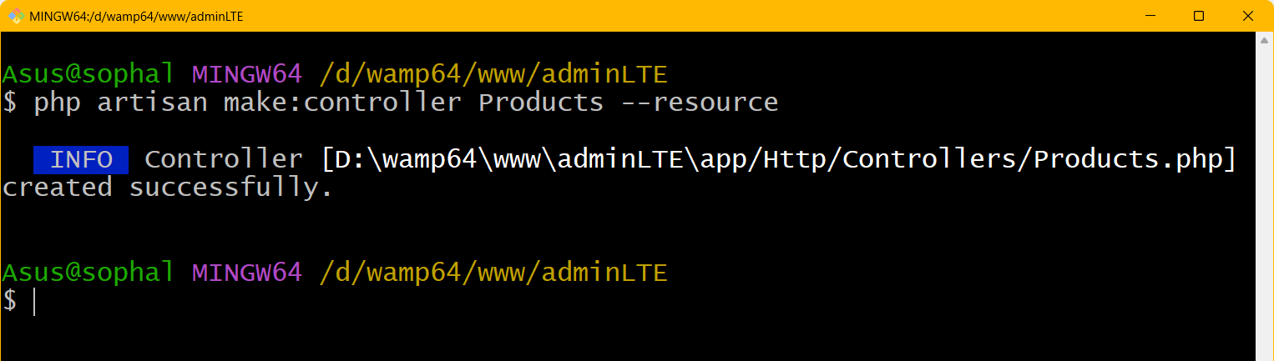

This will add ProductsController.php at app/Http/Controllers/. You can take a look at this file that already contains some empty predefined methods but we are going to be updating those soon.

[ProductsController.php](http://estebanpayret.com/laravel-crud-create-read-update-and-delete/)

First, open routes/web.php and add some code.

<?php

namespace App\Http\Controllers;

use Illuminate\Http\Request;

class Products extends Controller

{

    /**

     * Display a listing of the resource.

     */

    public function index()

    {

        //

    }

    /**

     * Show the form for creating a new resource.

     */

    public function create()

    {

        //

    }

    /**

     * Store a newly created resource in storage.

     */

    public function store(Request $request)

    {

        //

    }

    /**

     * Display the specified resource.

     */

    public function show(string $id)

    {

        //

    }

    /**

     * Show the form for editing the specified resource.

     */

    public function edit(string $id)

    {

        //

    }

    /**

     * Update the specified resource in storage.

     */

    public function update(Request $request, string $id)

    {

        //

    }

    /**

     * Remove the specified resource from storage.

     */

    public function destroy(string $id)

    {

        //

    }

}

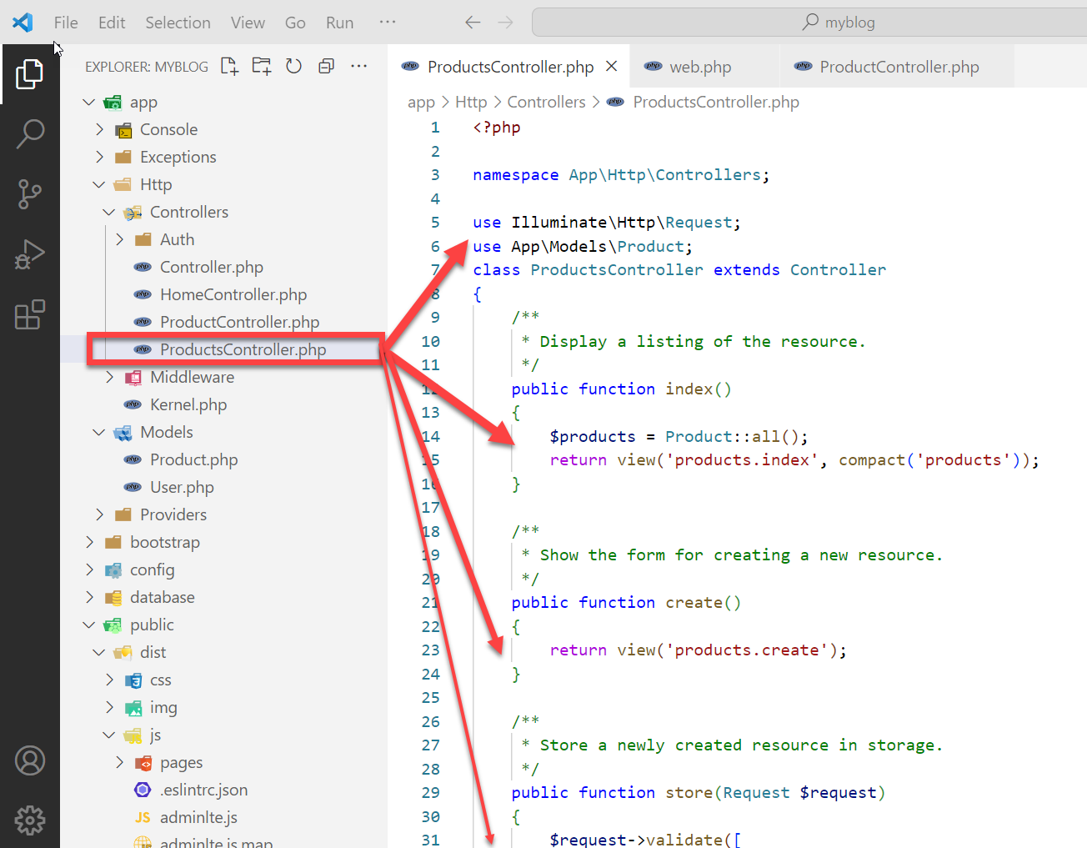

Source code:

<?php

namespace App\Http\Controllers;

use Illuminate\Http\Request;

use App\Models\Product;

class ProductsController extends Controller

{

    /**

     * Display a listing of the resource.

     */

    public function index()

    {

        $products = Product::all();

        return view('products.index', compact('products'));

    }

    /**

     * Show the form for creating a new resource.

     */

    public function create()

    {

        return view('products.create');

    }

    /**

     * Store a newly created resource in storage.

     */

    public function store(Request $request)

    {

        $request->validate([

            'product_name' =>'required',

            'qty' =>'required',

            'unit_price' =>'required',

        ]);

        $product = new Product;

        $product->product_name = $request->product_name;

        $product->qty = $request->qty;

        $product->unit_price = $request->unit_price;

        $product->save();

        return redirect()->route('products.index');

    }

    /**

     * Display the specified resource.

     */

    public function show(string $id)

    {

        $product = Product::find($id);

        return view('products.show', compact('product'));

    }

    /**

     * Show the form for editing the specified resource.

     */

    public function edit(string $id)

    {

        $product = Product::find($id);

        return view('products.edit', compact('product'));

    }

    /**

     * Update the specified resource in storage.

     */

    public function update(Request $request, string $id)

    {

        $product = Product::find($id);

        $product->product_name = $request->input('product_name');

        $product->qty = $request->input('qty');

        $product->unit_price = $request->input('unit_price');

        $product->save();

        return redirect('/products');

    }

    /**

     * Remove the specified resource from storage.

     */

    public function destroy(string $id)

    {

        $product = Product::find($id);

        $product->delete();

        return redirect('/products');

    }

}

**Route ► wep.php**

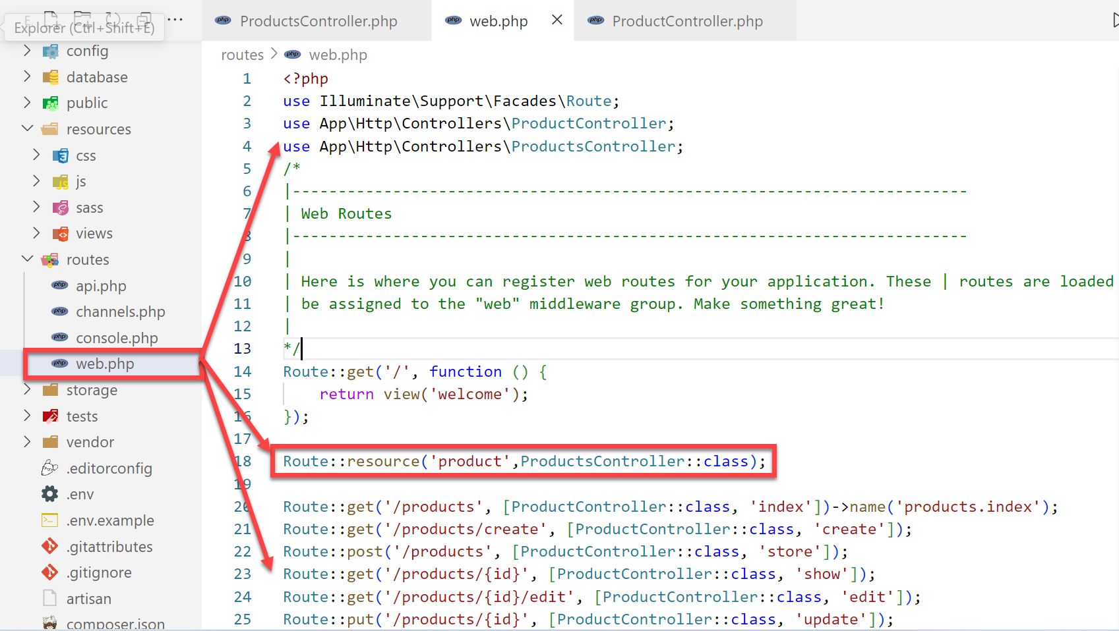

<?php

use Illuminate\Support\Facades\Route;

use App\Http\Controllers\ProductController;

**use App\Http\Controllers\ProductsController;**

/*

|--------------------------------------------------------------------------

| Web Routes

|--------------------------------------------------------------------------

|

| Here is where you can register web routes for your application. These | routes are loaded by the RouteServiceProvider and all of them will

| be assigned to the "web" middleware group. Make something great!

|

*/

Route::get('/', function () {

    return view('welcome');

});

**Route::resource('product',ProductsController::class);**

Route::get('/products', [ProductController::class, 'index'])->name('products.index');

Route::get('/products/create', [ProductController::class, 'create']);

Route::post('/products', [ProductController::class, 'store']);

Route::get('/products/{id}', [ProductController::class, 'show']);

Route::get('/products/{id}/edit', [ProductController::class, 'edit']);

Route::put('/products/{id}', [ProductController::class, 'update']);

Route::delete('/products/{id}', [ProductController::class, 'destroy']);

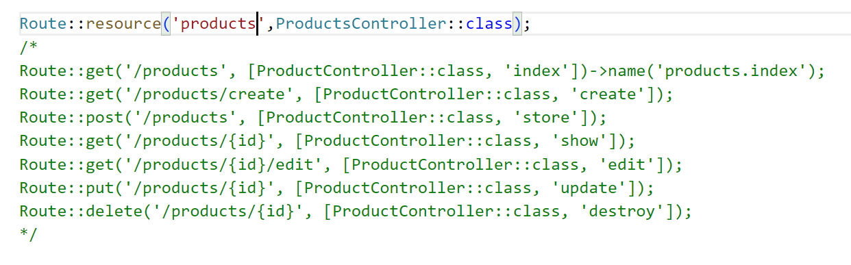

Check list of route

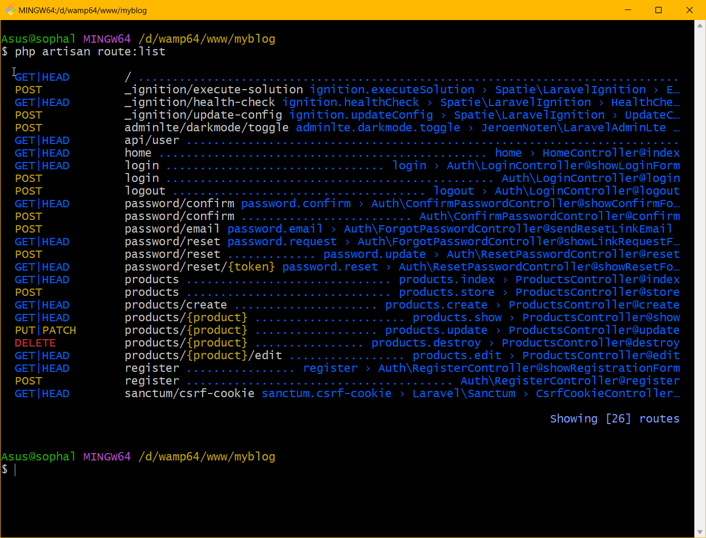

**To be Continue Part C**

**Fetching Data with Pagination:**

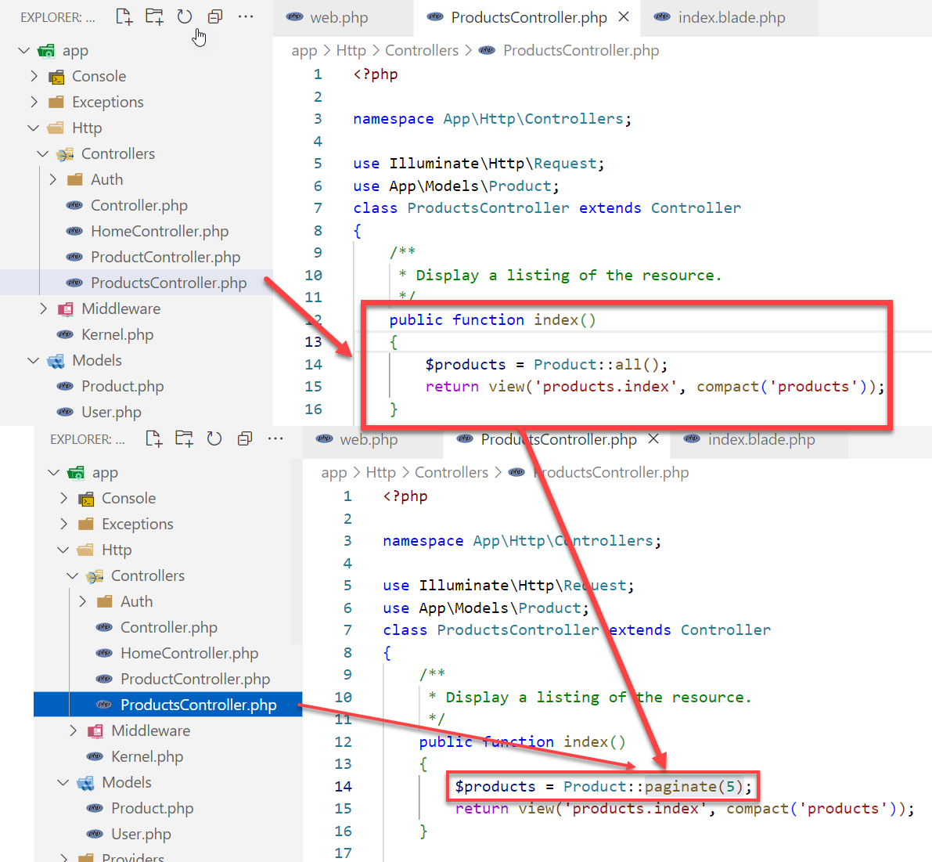

    public function index()

    {

        $products = Product::paginate(5);

        return view('products.index', compact('products'));

    }

**Displaying Data with AdminLTE in index.blade.php**:

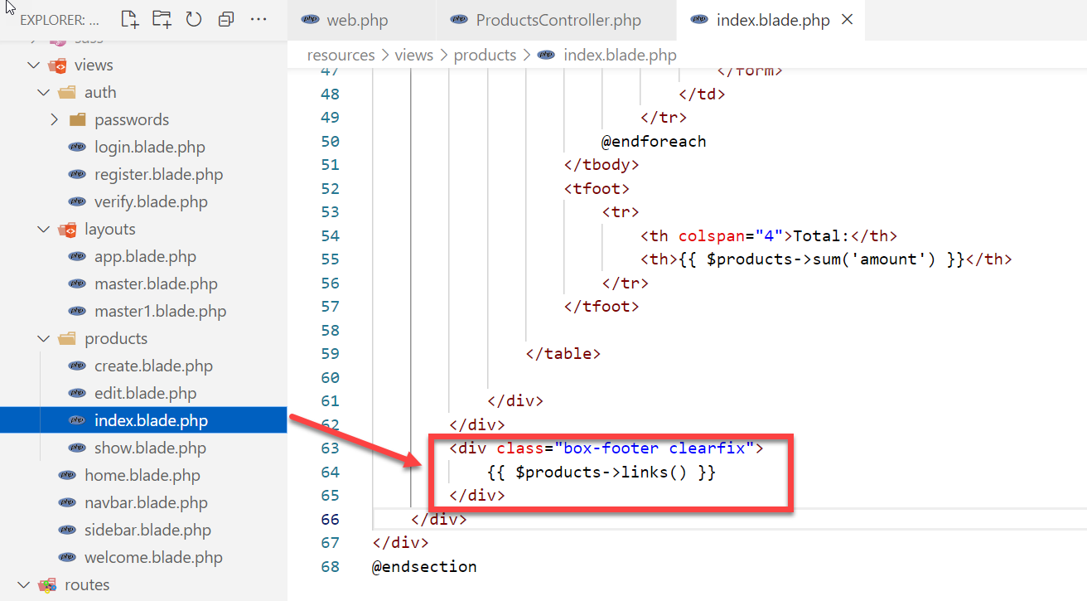

**1. Create a New Pagination View**

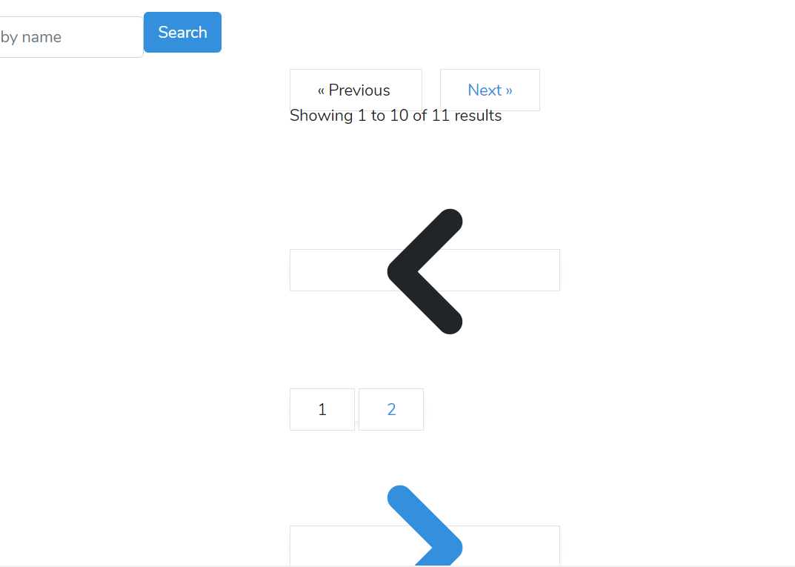

First, create a new blade file for your custom pagination. Navigate to the resources/views/vendor/pagination directory (create it if it doesn't exist) and create a file named adminlte.blade.php.

**2. Customize the Pagination View**

Edit the adminlte.blade.php file. Use the structure of AdminLTE buttons and layouts to customize the look of your pagination.

Here's a basic example:

@if ($paginator->hasPages())

<ul class="pagination">

{{-- Previous Page Link --}}

@if ($paginator->onFirstPage())

<li class="page-item disabled"><a class="page-link">« Previous</a></li>

@else

<li class="page-item"><a class="page-link" href="{{ $paginator->previousPageUrl() }}" rel="prev">« Previous</a></li>

@endif

{{-- Pagination Elements --}}

@foreach ($elements as $element)

{{-- Array Of Links --}}

@if (is_array($element))

@foreach ($element as $page => $url)

@if ($page == $paginator->currentPage())

<li class="page-item active"><a class="page-link">{{ $page }}</a></li>

@else

<li class="page-item"><a class="page-link" href="{{ $url }}">{{ $page }}</a></li>

@endif

@endforeach

@endif

@endforeach

{{-- Next Page Link --}}

@if ($paginator->hasMorePages())

<li class="page-item"><a class="page-link" href="{{ $paginator->nextPageUrl() }}" rel="next">Next »</a></li>

@else

<li class="page-item disabled"><a class="page-link">Next »</a></li>

@endif

</ul>

@endif

**3. Use the Custom Pagination View**

In your blade file where you want to display the pagination, use:

{{ $yourData->links('vendor.pagination.adminlte') }}

**4. Apply AdminLTE Styles**

Ensure you've included AdminLTE's CSS in your view, which should naturally style the pagination, making it fit the overall theme.

integrate AdminLTE with Laravel and then customize the pagination view.

**1. Integrating AdminLTE with Laravel:**

1. **Install a New Laravel Project** (if you haven't already):

bashCopy code

composer create-project laravel/laravel project-name

1. **Install the AdminLTE package**:

bashCopy code

composer require almasaeed2010/adminlte

1. **Publish the public assets**:

bashCopy code

**php artisan vendor:publish --tag=assets**

**2. Custom Pagination View:**

1. **Publish Laravel's default pagination views**:

bashCopy code

**php artisan vendor:publish --tag=laravel-pagination**

This command will publish pagination views to **resources/views/vendor/pagination**.

1. **Customize the Bootstrap 4 View**:

Now, navigate to **resources/views/vendor/pagination** and open the **bootstrap-4.blade.php** file.

Modify this file according to your requirements. Since you're using AdminLTE (which is based on Bootstrap), it'll be easier to customize the Bootstrap's pagination view.

For example, to add custom classes or colors, find the following line:

htmlCopy code

<li class="page-item">

And modify it, for example:

htmlCopy code

<li class="page-item custom-class">

Similarly, style the active and disabled states.

**3. Use the Custom Pagination View in Your Blade Files:**

Whenever you want to display pagination in your views, use:

phpCopy code

{{ $yourData->links() }}

This will use your customized pagination view.

**Notes:**

1. Make sure you've included AdminLTE CSS and JS in your layout/views. AdminLTE's CSS will naturally style the pagination if you're using Bootstrap-based pagination views.
2. Always check the AdminLTE documentation for additional components and utilities which can help in customizing your application further.

**Part D**

**To Be Continue**

Here are more details on generating a UserController resource with CRUD operations in Laravel:

**1. Generate Controller**

Use the --resource flag to generate a resource controller:

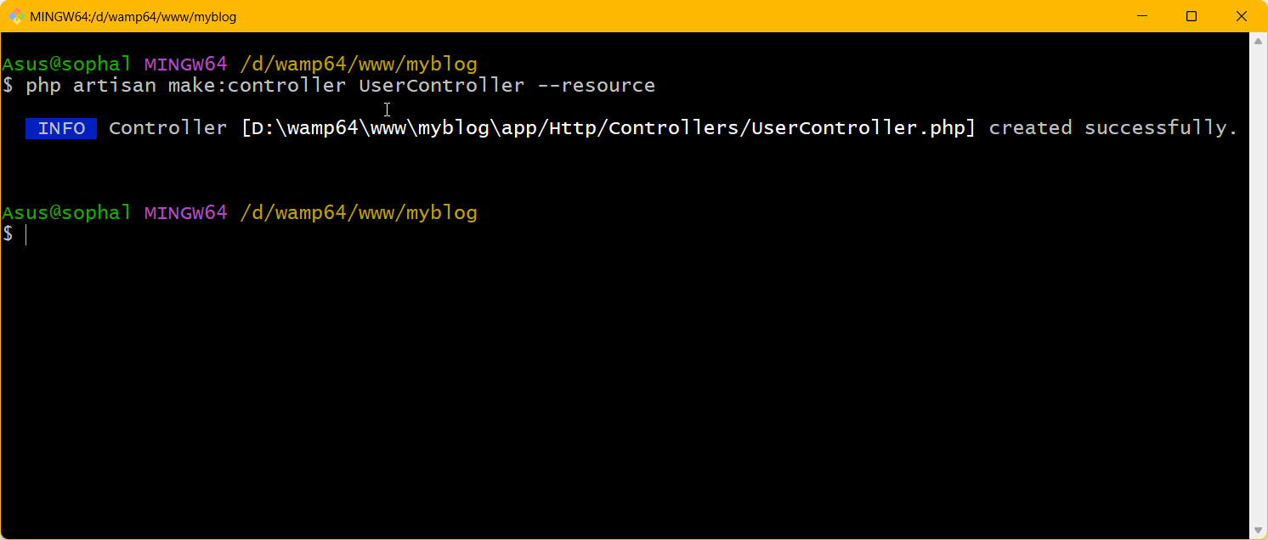

bash

Copy

php artisan make:controller UserController --resource

This will create the controller with default CRUD methods like index(), create(), store() etc.

**2. Add Routes**

Map resource routes in routes/web.php:

php

Copy

Route::resource('users', UserController::class);

**3. CRUD Methods**

* index() - Gets all users from DB and passes to view
* create() - Shows form to create new user
* store(Request $request) - Validates and stores new user
* show($id) - Gets single user by ID and passes to view
* edit($id) - Shows edit form for user
* update(Request $request, $id) - Validates and updates user
* destroy($id) - Deletes user from database

**4. Views**

* index.blade.php - Lists all users
* create.blade.php - Form to create new user
* edit.blade.php - Form to edit existing user
* show.blade.php - Details of single user

**5. Database**

Run migrations to create users table. The controller methods will interact with this table to CRUD data.

**6. Authorization**

Use Laravel Gates or Policies to authorize CRUD actions like update/delete for authenticated users.

Let me know if you need any example code for these steps! The goal is to start with the generated resource controller and customize it for your specific user management needs.

**1. Create Layout or Master Layouts**

Start with a base layout at resources/views/layouts/app.blade.php that extends your admin template and defines common elements like navbar, footer etc.

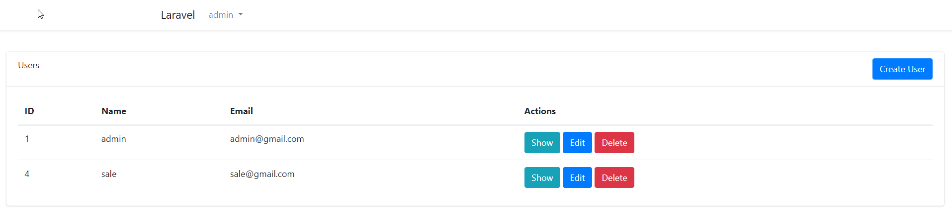

<!doctype html>

<html lang="{{ str_replace('_', '-', app()->getLocale()) }}">

<head>

    <meta charset="utf-8">

    <meta name="viewport" content="width=device-width, initial-scale=1">

    <!-- CSRF Token -->

    <meta name="csrf-token" content="{{ csrf_token() }}">

    <title>{{ config('app.name', 'Laravel') }}</title>

    <!-- Include AdminLTE CSS -->

    <link rel="stylesheet" href="{{ asset('vendor/adminlte/dist/css/adminlte.min.css') }}">

    <!-- Include AdminLTE JS -->

    <script src="{{ asset('vendor/adminlte/dist/js/adminlte.min.js') }}"></script>

    <!-- Fonts -->

    <link rel="dns-prefetch" href="//fonts.bunny.net">

    <link href="https://fonts.bunny.net/css?family=Nunito" rel="stylesheet">

    <!-- Scripts -->

    @vite(['resources/sass/app.scss', 'resources/js/app.js'])

</head>

<body>

    <div id="app">

        <nav class="navbar navbar-expand-md navbar-light bg-white shadow-sm">

            <div class="container">

                <a class="navbar-brand" href="{{ url('/') }}">

                    {{ config('app.name', 'Laravel') }}

                </a>

                <button class="navbar-toggler" type="button" data-bs-toggle="collapse" data-bs-target="#navbarSupportedContent" aria-controls="navbarSupportedContent" aria-expanded="false" aria-label="{{ __('Toggle navigation') }}">

                    <span class="navbar-toggler-icon"></span>

                </button>

                <div class="collapse navbar-collapse" id="navbarSupportedContent">

                    <!-- Left Side Of Navbar -->

                    <ul class="navbar-nav me-auto">

                    </ul>

                    <!-- Right Side Of Navbar -->

                    <ul class="navbar-nav ms-auto">

                        <!-- Authentication Links -->

                        @guest

                            @if (Route::has('login'))

                                <li class="nav-item">

                                    <a class="nav-link" href="{{ route('login') }}">{{ __('Login') }}</a>

                                </li>

                            @endif

                            @if (Route::has('register'))

                                <li class="nav-item">

                                    <a class="nav-link" href="{{ route('register') }}">{{ __('Register') }}</a>

                                </li>

                            @endif

                        @else

                            <li class="nav-item dropdown">

                                <a id="navbarDropdown" class="nav-link dropdown-toggle" href="#" role="button" data-bs-toggle="dropdown" aria-haspopup="true" aria-expanded="false" v-pre>

                                    {{ Auth::user()->name }}

                                </a>

                                <div class="dropdown-menu dropdown-menu-end" aria-labelledby="navbarDropdown">

                                    <a class="dropdown-item" href="{{ route('logout') }}"

                                       onclick="event.preventDefault();

                                                     document.getElementById('logout-form').submit();">

                                        {{ __('Logout') }}

                                    </a>

                                    <form id="logout-form" action="{{ route('logout') }}" method="POST" class="d-none">

                                        @csrf

                                    </form>

                                </div>

                            </li>

                        @endguest

                    </ul>

                </div>

            </div>

        </nav>

        <main class="py-4">

            @yield('content')

        </main>

    </div>

</body>

</html>

**or Master Layouts**

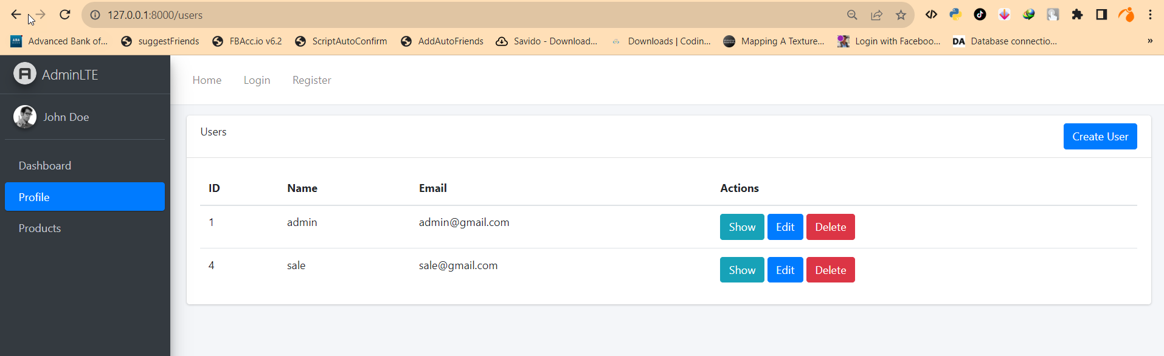

<!DOCTYPE html>

<html lang="en">

<head>

    <meta charset="UTF-8">

    <meta name="viewport" content="width=device-width, initial-scale=1.0">

    <title>@yield('title', 'AdminLTE Template')</title>

    <!-- AdminLTE CSS -->

    <link rel="stylesheet" href="{{ asset('/dist/css/adminlte.min.css') }}">

    <!-- Styles -->

    <link href="{{ asset('/css/custom.css') }}" rel="stylesheet">

    <!-- Additional CSS -->

    @yield('css')

    <!-- AdminLTE JavaScript -->

    <script src="{{ asset('/dist/js/adminlte.min.js') }}"></script>

    <!-- Additional JavaScript -->

    @yield('js')

</head>

<body class="hold-transition sidebar-mini">

    <!-- Main Content Wrapper -->

    <div class="wrapper">

        <!-- Navbar -->

        <nav class="main-header navbar navbar-expand navbar-white navbar-light">

            <!-- Navbar content here -->

            <!-- Include the navbar -->

    @include('navbar')

        </nav>

        <!-- Sidebar -->

        <aside class="main-sidebar sidebar-dark-primary elevation-4">

            <!-- Sidebar content here -->

           <!-- Include the sidebar -->

    @include('sidebar')

        </aside>

        <!-- Content Wrapper -->

        <div class="content-wrapper">

            <!-- Content here -->

            <section class="content">

                @yield('content')

            </section>

        </div>

    </div>

</body>

</html>

**2. Index View**

resources/views/users/index.blade.php:

* Extend layout
* Loop through $users collection
* Display user details in a table or cards
* Render pagination links

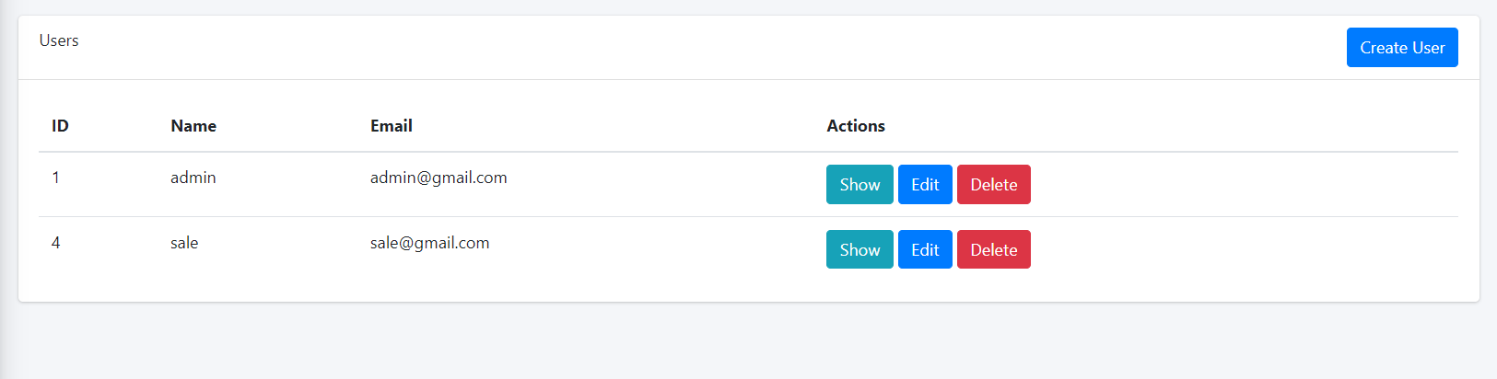

@extends('layouts.master')

@section('content')

<div class="content-header">

    <div class="container-fluid">

        <div class="row justify-content-center">

            <div class="col-md-12">

            <div class="card">

                <div class="card-header">

                Users

                <a href="{{ route('users.create') }}" class="btn btn-primary float-right">Create User</a>

                </div>

                <div class="card-body">

                <table class="table">

                    <thead>

                    <tr>

                        <th>ID</th>

                        <th>Name</th>

                        <th>Email</th>

                        <th>Actions</th>

                    </tr>

                    </thead>

                    <tbody>

                    @foreach ($users as $user)

                        <tr>

                        <td>{{ $user->id }}</td>

                        <td>{{ $user->name }}</td>

                        <td>{{ $user->email }}</td>

                        <td>

                            <a href="{{ route('users.show', $user) }}" class="btn btn-info">Show</a>

                            <a href="{{ route('users.edit', $user) }}" class="btn btn-primary">Edit</a>

                            <form action="{{ route('users.destroy', $user) }}" method="POST" style="display: inline">

                            @csrf

                            @method('DELETE')

                            <button class="btn btn-danger" type="submit" onclick="return confirm('sure to delete !');">Delete</button>

                            </form>

                        </td>

                        </tr>

                    @endforeach

                    </tbody>

                </table>

                {!! $users->links() !!}

                </div>

            </div>

            </div>

        </div>

    </div>

</div>

@endsection

**3. Create View**

resources/views/users/create.blade.php:

* Extend layout
* Form to create new user
  + Input fields for name, email, password etc
  + Submit button

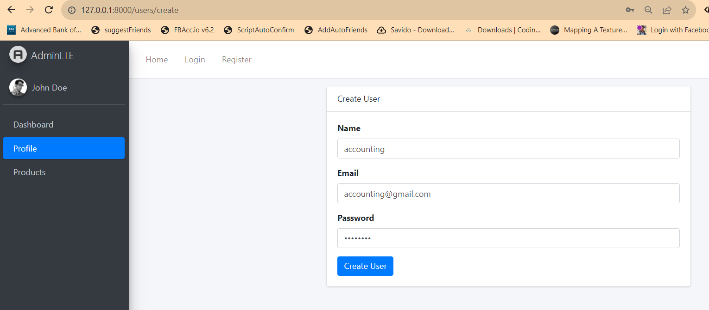

@extends('layouts.master')

@section('content')

<div class="content-header">

    <div class="container-fluid">

      <div class="row justify-content-center">

        <div class="col-md-6">

          <div class="card">

            <div class="card-header">

              Create User

            </div>

            <div class="card-body">

              <form action="{{ route('users.store') }}" method="POST">

                @csrf

                <div class="form-group">

                  <label>Name</label>

                  <input type="text" name="name" class="form-control">

                </div>

                <div class="form-group">

                  <label>Email</label>

                  <input type="email" name="email" class="form-control">

                </div>

                <div class="form-group">

                  <label>Password</label>

                  <input type="password" name="password" class="form-control">

                </div>

                <button type="submit" class="btn btn-primary">Create User</button>

              </form>

            </div>

          </div>

        </div>

      </div>

    </div>

</div>

@endsection

**4. Edit View**

resources/views/users/edit.blade.php:

* Extend layout
* Form to edit user
  + Populate fields with existing user data
  + Submit button

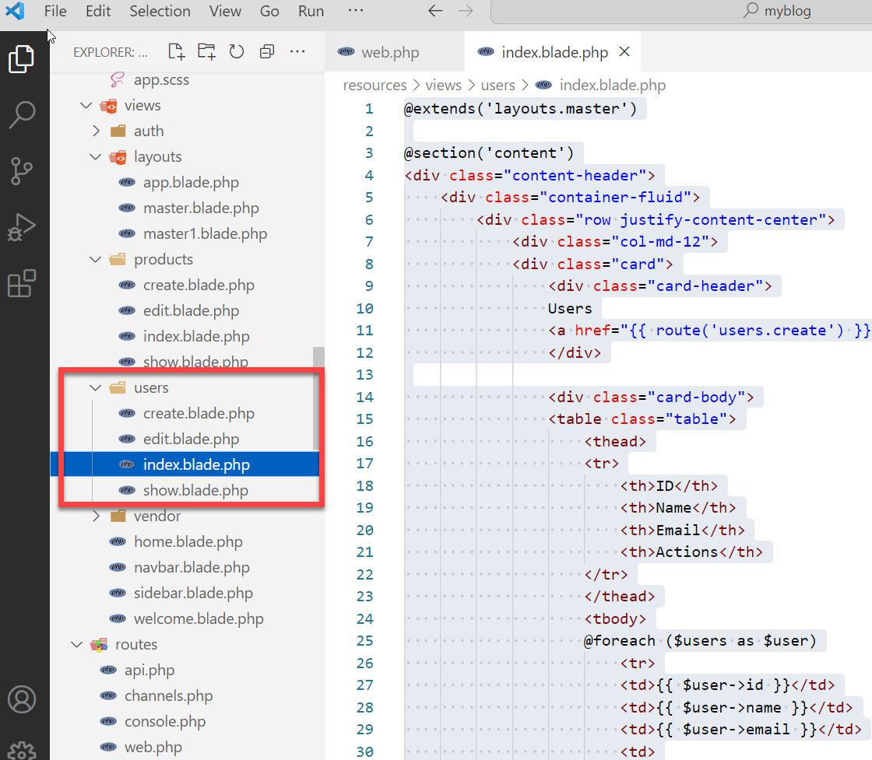

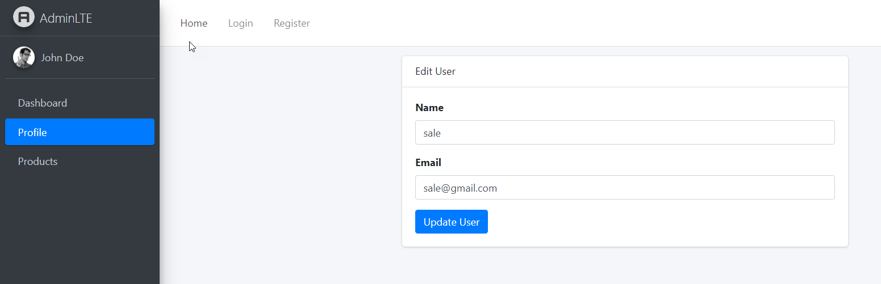

@extends('layouts.master')

@section('content')

<div class="content-header">

    <div class="container-fluid">

      <div class="row justify-content-center">

        <div class="col-md-6">

          <div class="card">

            <div class="card-header">

              Edit User

            </div>

            <div class="card-body">

              <form action="{{ route('users.update', $user) }}" method="POST">

                @csrf

                @method('PUT')

                <div class="form-group">

                  <label>Name</label>

                  <input type="text" name="name" value="{{ $user->name }}" class="form-control">

                </div>

                <div class="form-group">

                  <label>Email</label>

                  <input type="email" name="email" value="{{ $user->email }}" class="form-control">

                </div>

                <button type="submit" class="btn btn-primary">Update User</button>

              </form>

            </div>

          </div>

        </div>

      </div>

    </div>

</div>

@endsection

**5. Show View**

resources/views/users/show.blade.php:

* Extend layout
* Display user details
  + Name, email, created_at etc

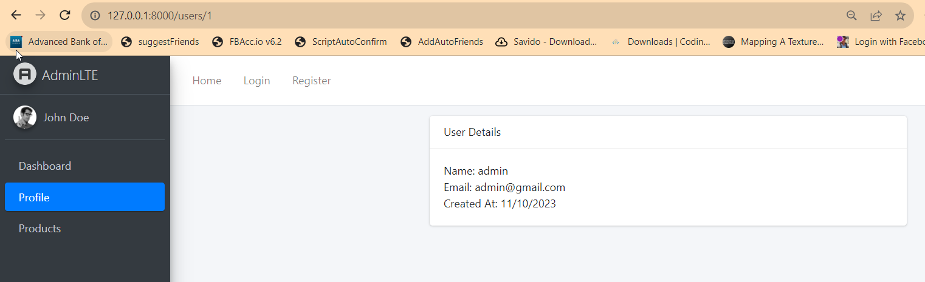

@extends('layouts.master')

@section('content')

<div class="content-header">

  <div class="container-fluid">

      <div class="row justify-content-center">

        <div class="col-md-6">

          <div class="card">

            <div class="card-header">

              User Details

            </div>

            <div class="card-body">

              Name: {{ $user->name }} <br>

              Email: {{ $user->email }} <br>

              Created At: {{ $user->created_at->format('d/m/Y') }}

            </div>

          </div>

        </div>

      </div>

  </div>

</div>

@endsection

**6. Create Controller**

UserController resource with CRUD operations and views in Laravel:

**UserController.php**

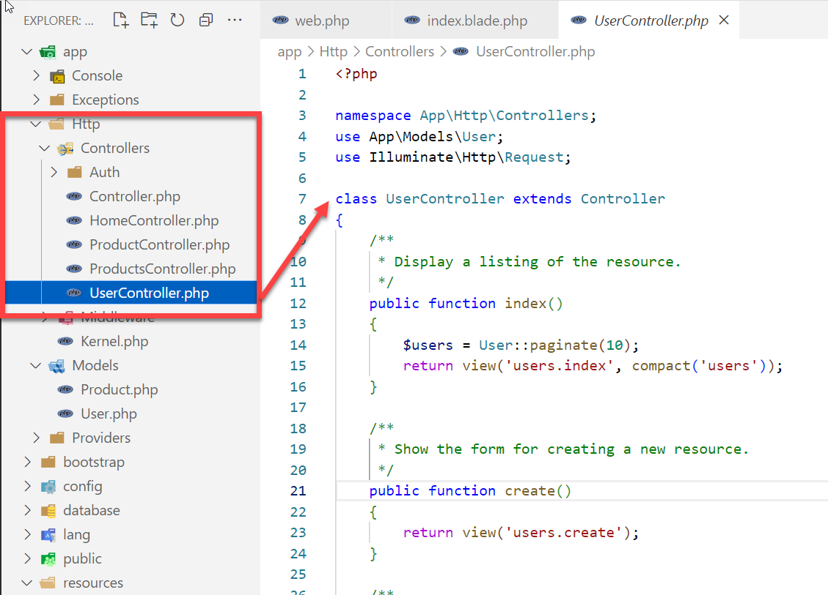

<?php

namespace App\Http\Controllers;

use App\Models\User;

use Illuminate\Http\Request;

class UserController extends Controller

{

    /**

     * Display a listing of the resource.

     */

    public function index()

    {

        $users = User::paginate(10);

        return view('users.index', compact('users'));

    }

    /**

     * Show the form for creating a new resource.

     */

    public function create()

    {

        return view('users.create');

    }

    /**

     * Store a newly created resource in storage.

     */

    public function store(Request $request)

    {

        // Validate form data

        $validateData = $request->validate([

            'name' => 'required|max:255',

            'email' => 'required|email|unique:users',

            'password' => 'required|min:6'

        ]);

        // Create user

        $user = User::create($validateData);

        // Redirect to index

        return redirect()->route('users.index')->with('success','User created successfully.');

    }

    /**

     * Display the specified resource.

     */

    public function show(User $user)

    {

        return view('users.show', compact('user'));

    }

    /**

     * Show the form for editing the specified resource.

     */

    public function edit(User $user)

    {

        return view('users.edit', compact('user'));

    }

    /**

     * Update the specified resource in storage.

     */

    public function update(Request $request, User $user)

    {

        // Validate form data

        $validateData = $request->validate([

            'name' => 'required|max:255',

            'email' => 'required|email|unique:users,email,' . $user->id

        ]);

        // Update user

        $user->update($validateData);

        // Redirect to index

        return redirect()->route('users.index')->with('success','User updated successfully');

    }

    /**

     * Remove the specified resource from storage.

     */

    public function destroy(User $user)

    {

        $user->delete();

        return redirect()->route('users.index')->with('success','User deleted successfully');

    }

}

**7. Routes**

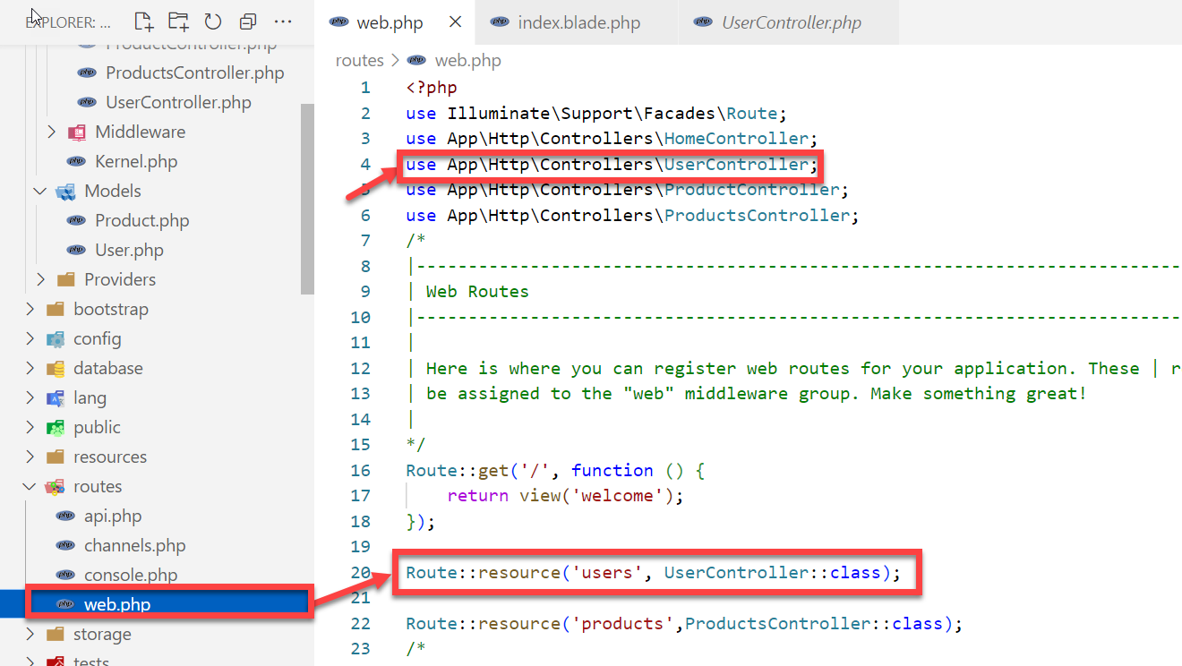

use App\Http\Controllers\UserController;

Route::resource('users', UserController::class);